Youtube Recommendation System

<https://www.youtube.com/watch?v=0nu83yWqnNQ>

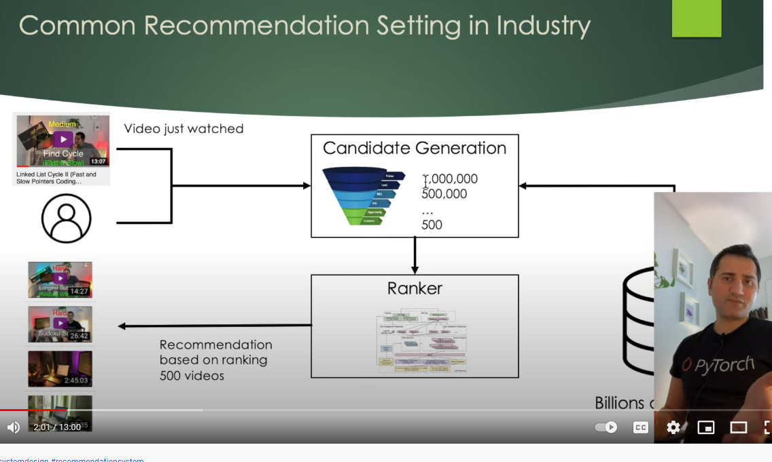

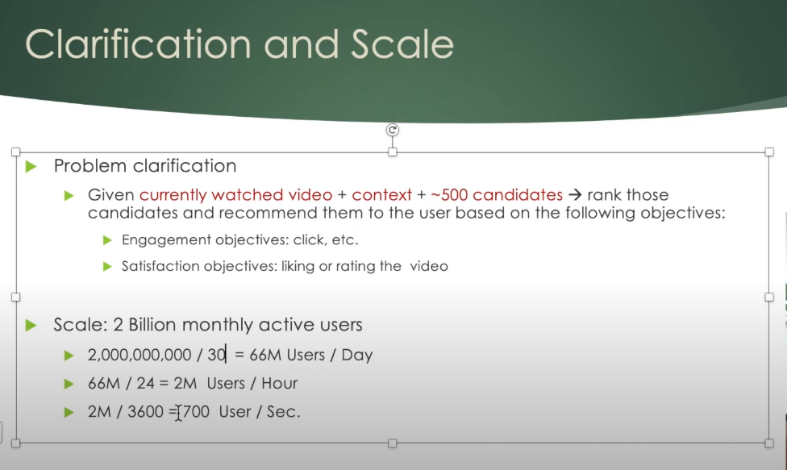

Engagement

Satisfaction

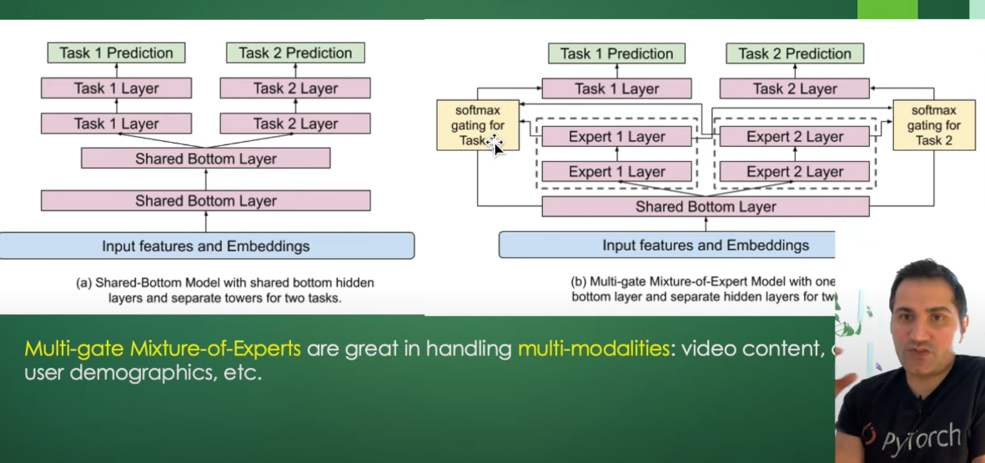

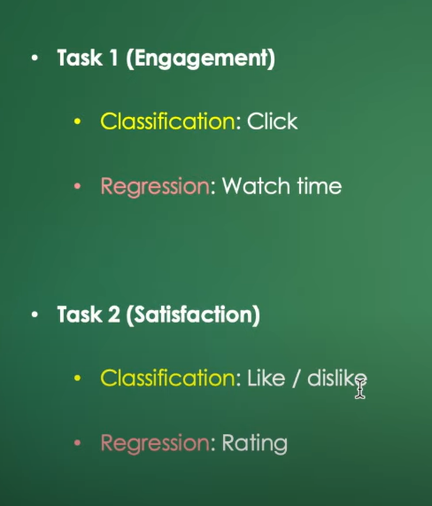

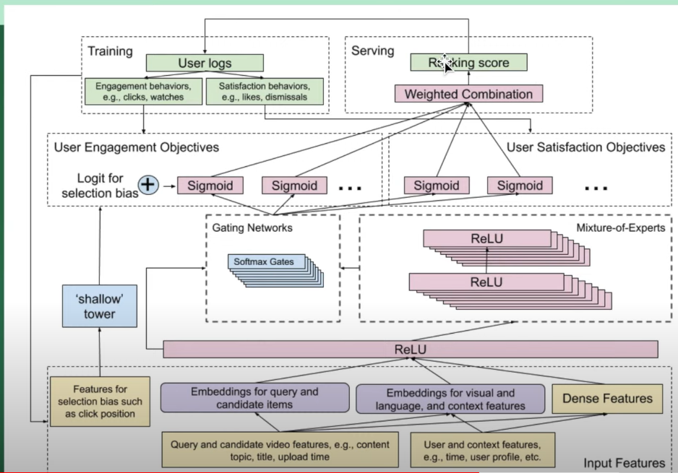

Position bias is important

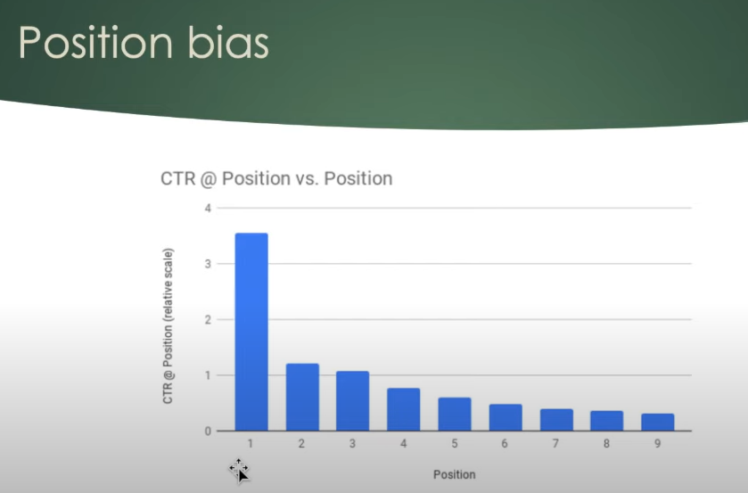

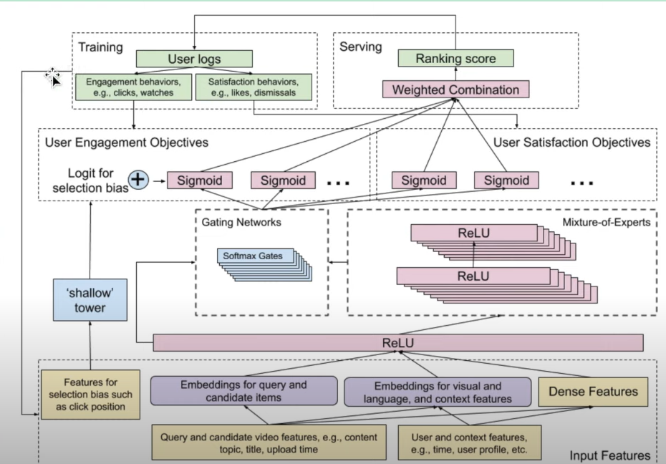

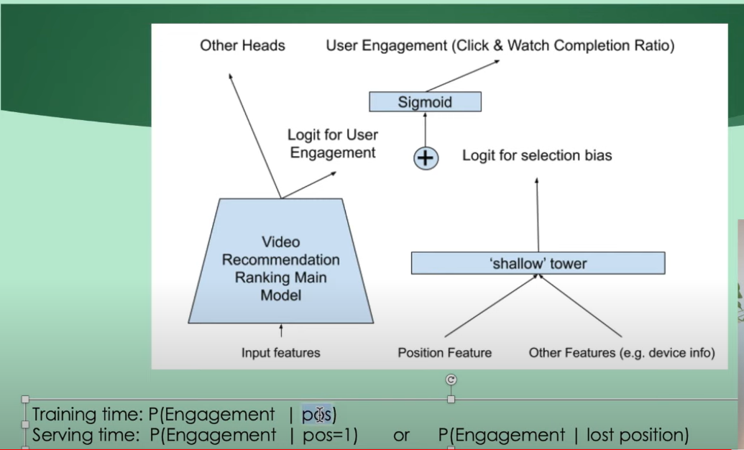

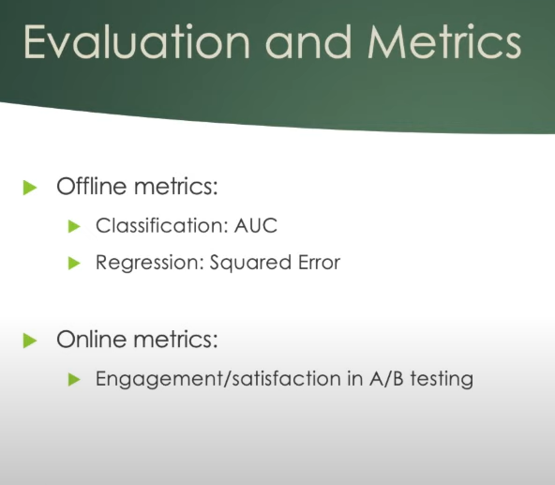

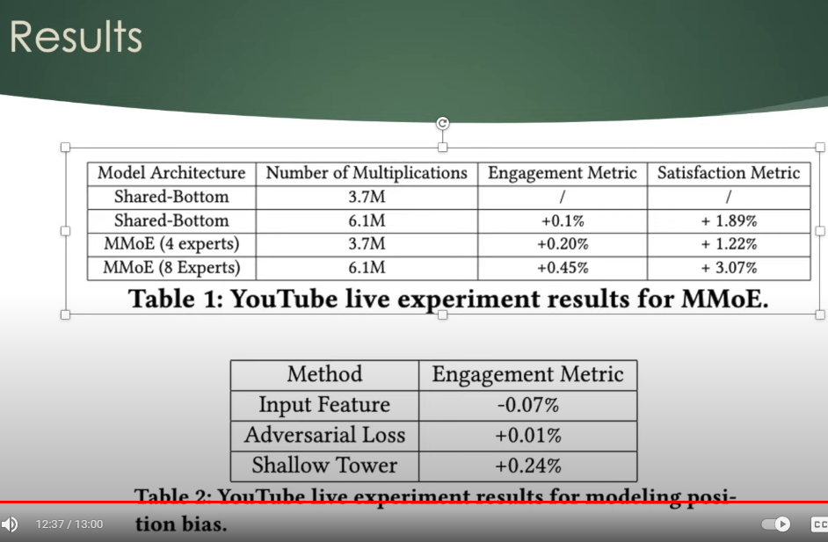

<https://www.youtube.com/watch?v=PH6cjPsij9s>

Data Scientist Interview - Machine Learning Project System Design | FAANG Mock Interview

Design an End-to-End ML System to design faulty mobile parts in manufacturing

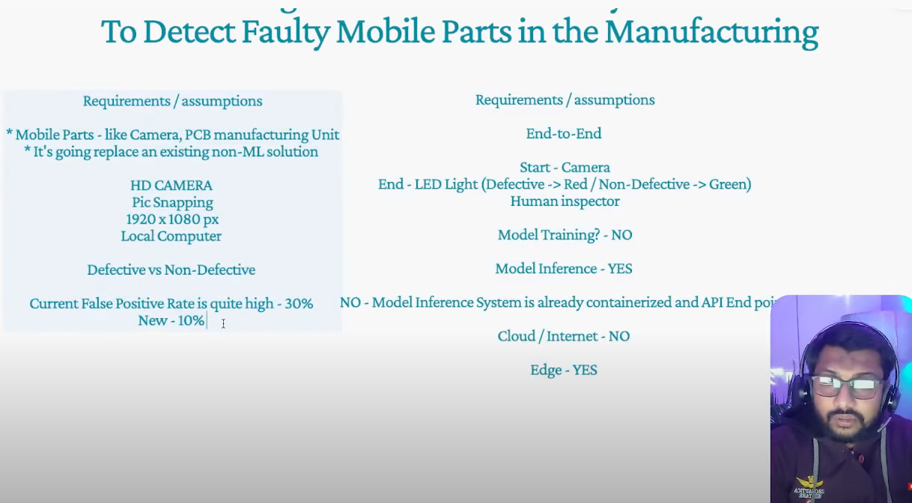

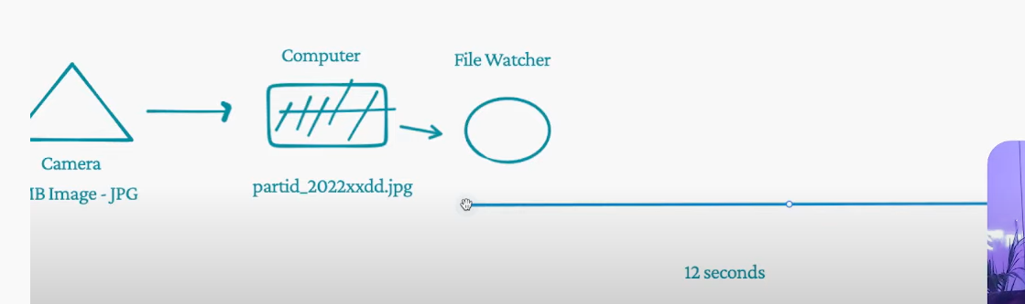

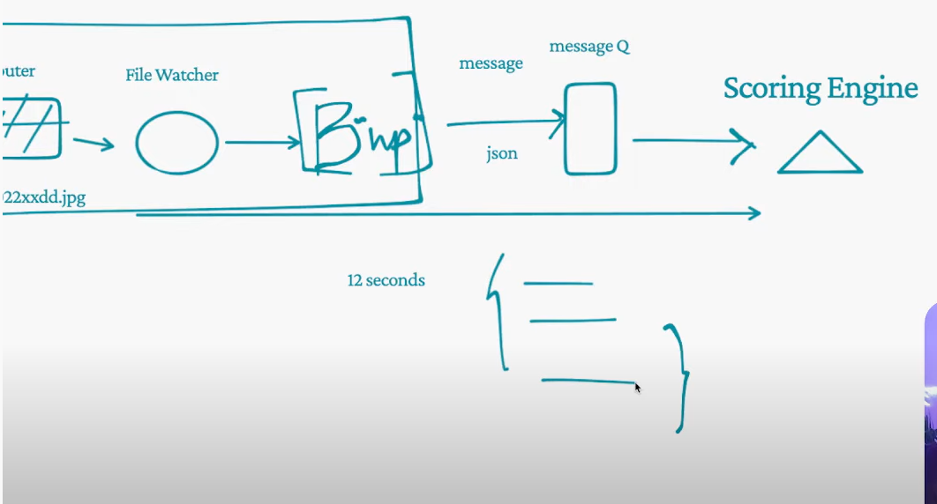

# Machine Learning design: Search engine for Q&A

<https://www.youtube.com/watch?v=J_0ms1ayqKE>

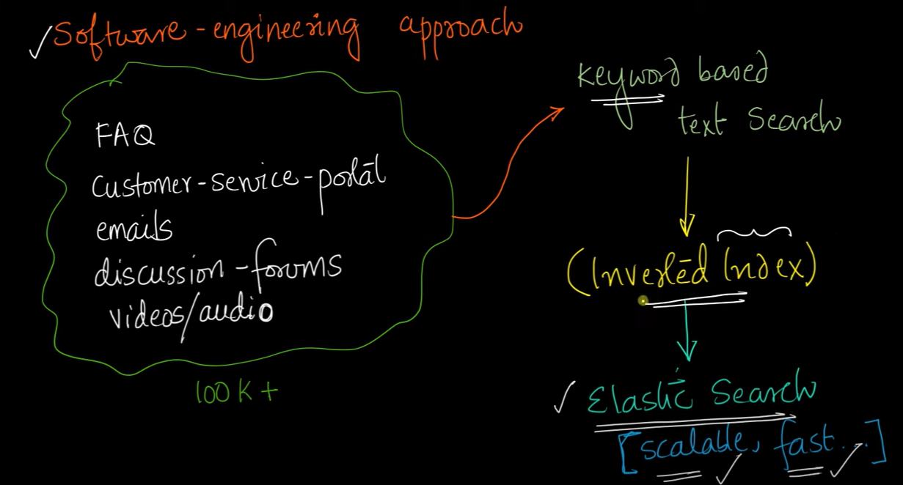

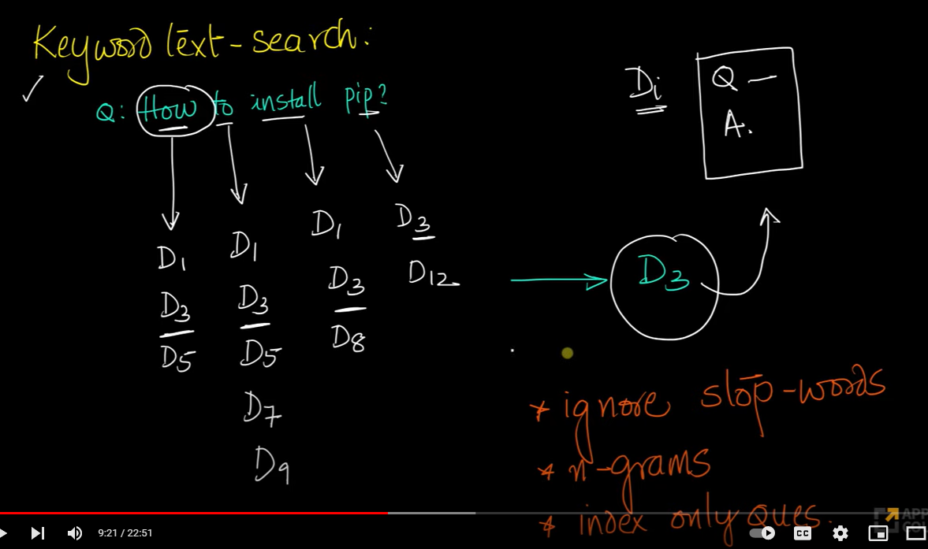

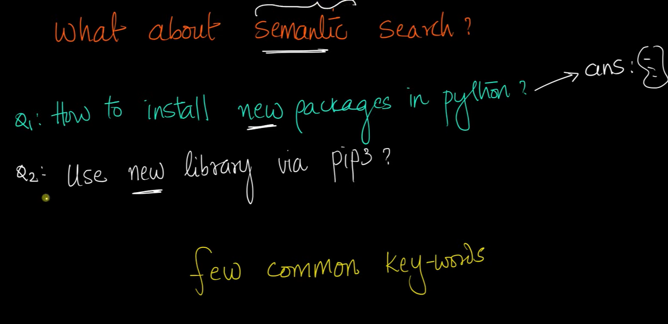

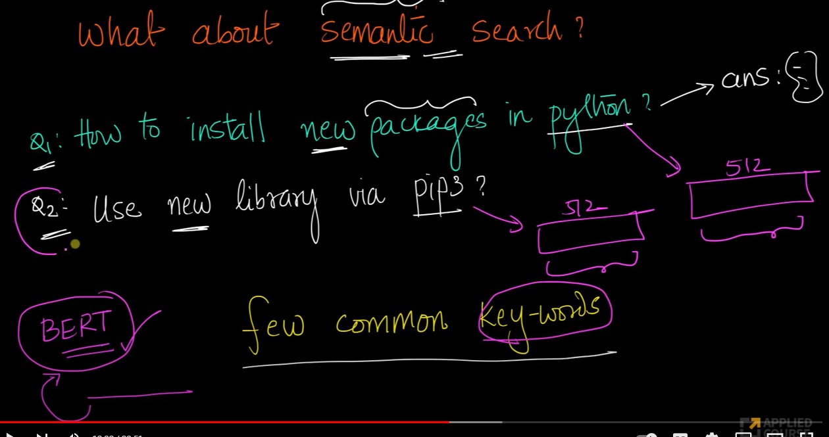

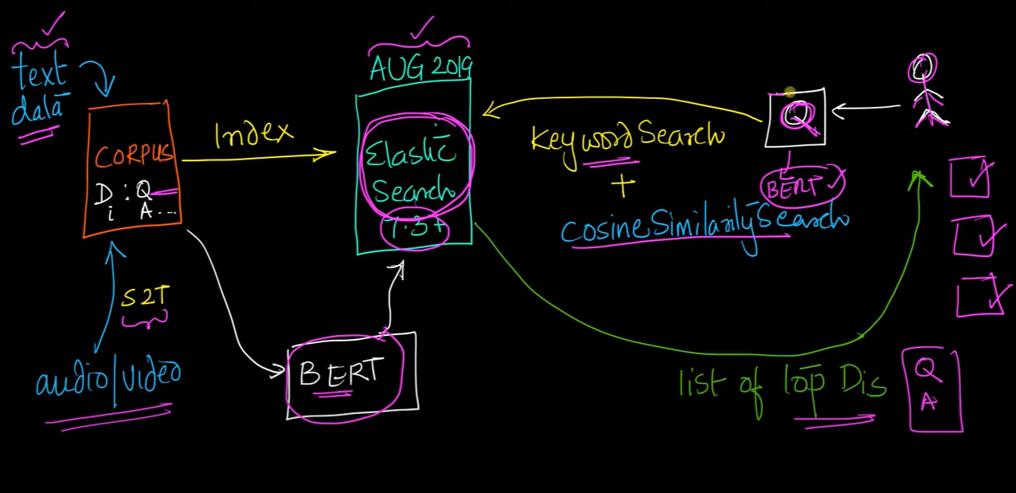

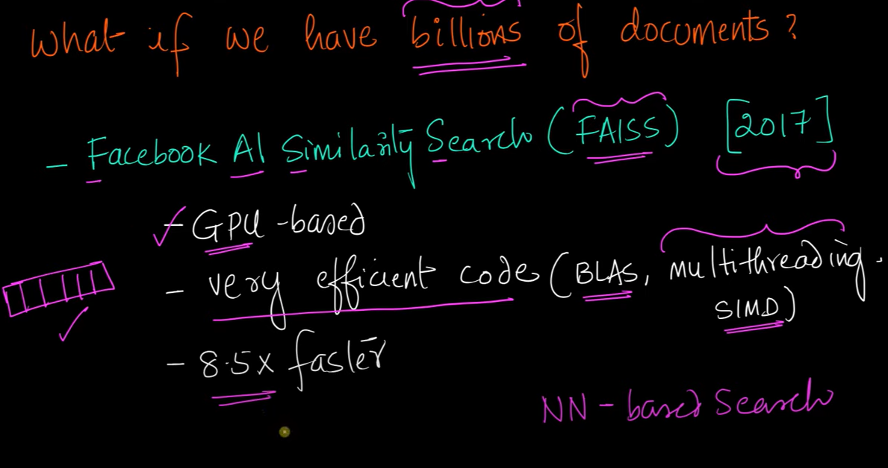

# Student Blog Post | Who is the Songster: Deep Learning Recognizes the singers of Bollywood songs

[**https://www.youtube.com/watch?v=rchbKqYjE_4&list=PLupD_xFct8mEx-tiLRPd4XS1XA-EchXNL**](https://www.youtube.com/watch?v=rchbKqYjE_4&list=PLupD_xFct8mEx-tiLRPd4XS1XA-EchXNL)

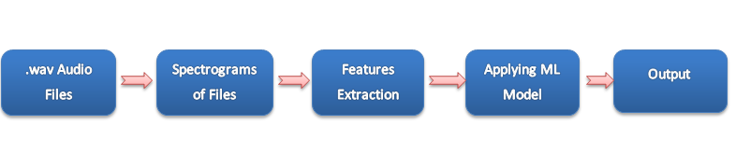

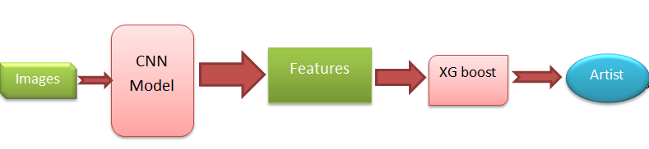

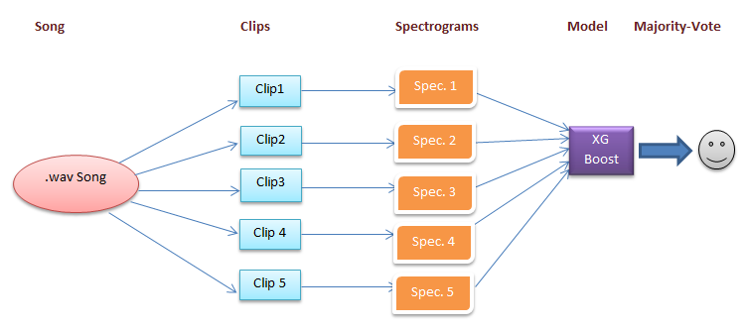

**Search Ranking**

[**https://yunrui-li.medium.com/ml-system-design-interview-search-ranking-system-85dc676cd4c0**](https://yunrui-li.medium.com/ml-system-design-interview-search-ranking-system-85dc676cd4c0)

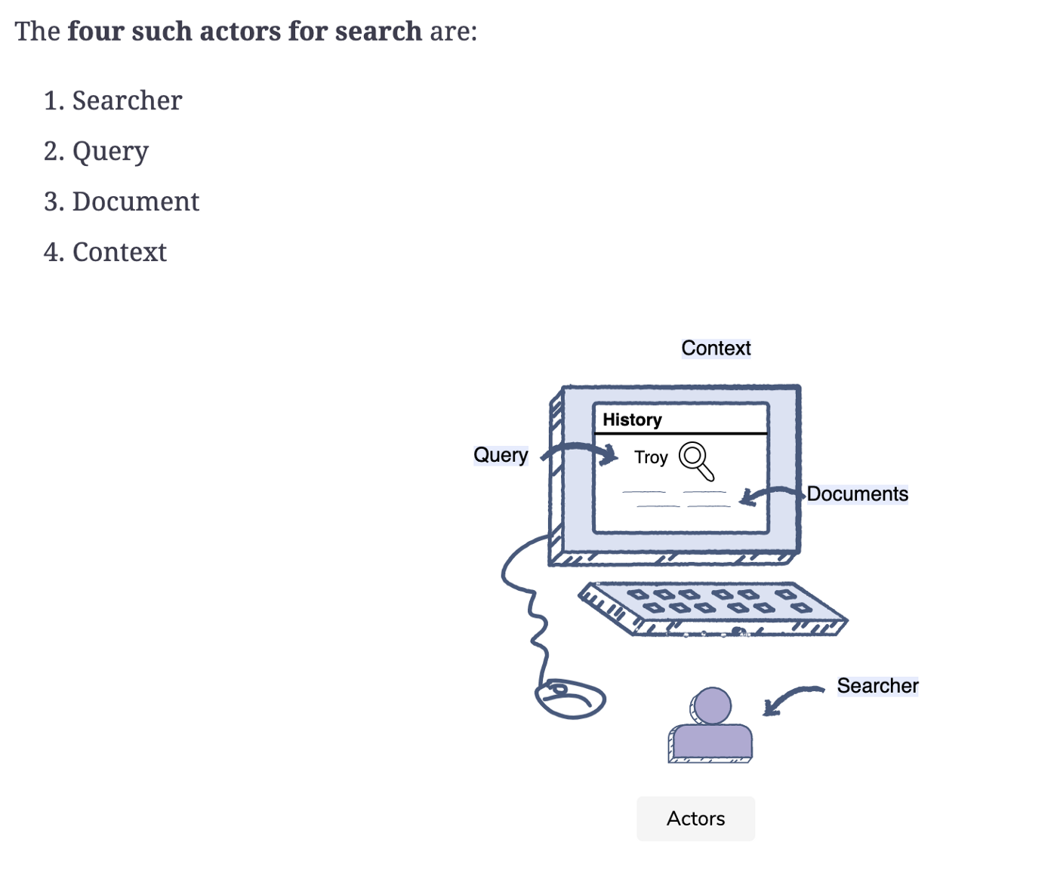

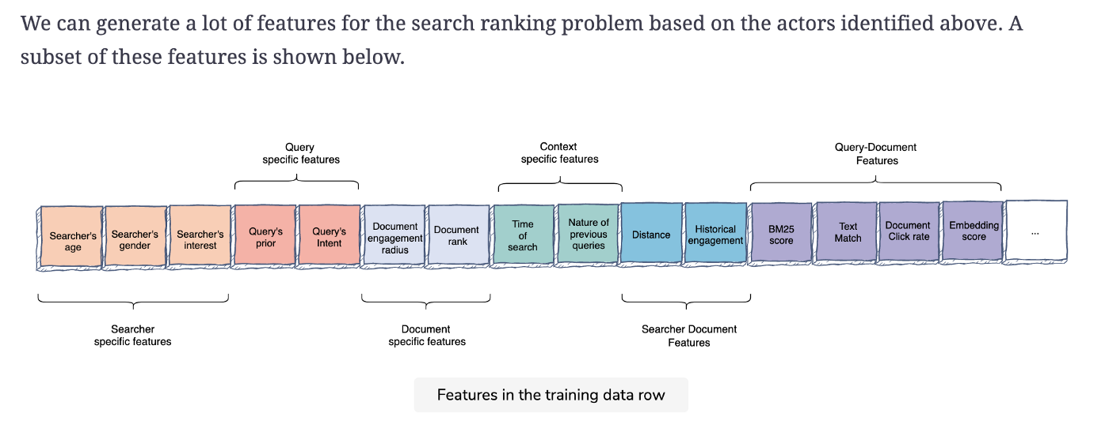

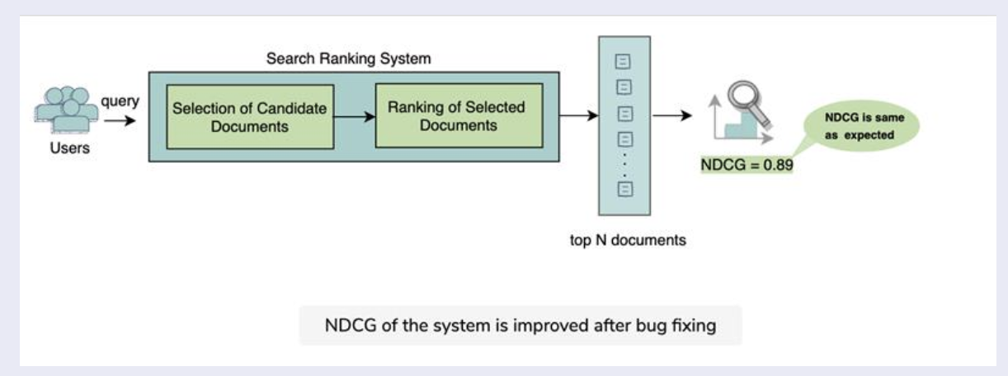

[**https://towardsdatascience.com/learning-to-rank-a-complete-guide-to-ranking-using-machine-learning-4c9688d370d4**](https://towardsdatascience.com/learning-to-rank-a-complete-guide-to-ranking-using-machine-learning-4c9688d370d4)

# Learning to Rank: A Complete Guide to Ranking using Machine Learning



[**https://www.educative.io/blog/cracking-machine-learning-interview-system-design**](https://www.educative.io/blog/cracking-machine-learning-interview-system-design)

### Performance and capacity considerations

* **Training time:** How much training data and capacity is needed to build our predictor?
* **Evaluation time:** What are the SLA that we have to meet while serving the model and capacity needs?

The **layered/funnel modeling** approach is the best way to solve for scale and relevance while keeping performance and capacity in check. You’ll start with a relatively fast model when you have the highest number of documents (e.g. 100 million documents in case of the search query “computer science”). In each later stage, you continue to increase the complexity (i.e. more optimized model in prediction) and execution time. The model needs to run on a reduced number of documents as the stages progress (e.g. your first stage could use a linear model and the final stage can use a deep neural network).

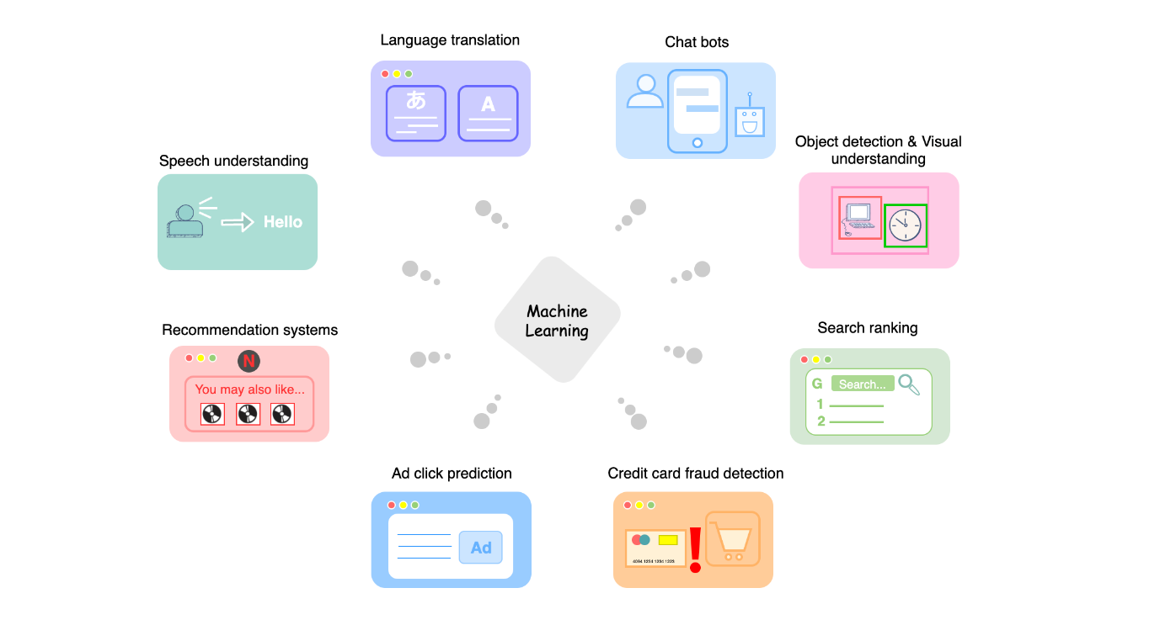

To run an online experiment, **A/B testing** is a great way to assess the impact of new features or changes in the system. In an A/B experiment, a second modified version of a webpage or screen is created. The original version is known as the *control*, and the modified version is the *variation*. From here, we can formulate two hypotheses:

* Null hypothesis
* Alternative hypothesis

We an also use this stage to measure long term effects with back testing and long-running A/B tests.

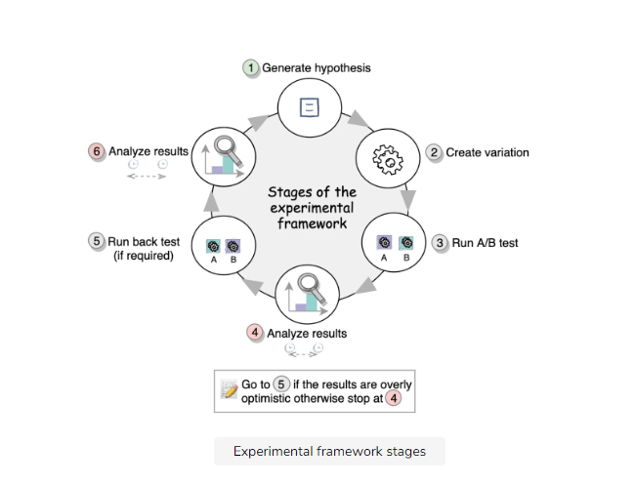

For example, if you are performing binary classification, you will use the following offline metrics: Area Under Curve (AUC), log loss, precision, recall, and F1-score.

When deciding on online metrics, you may need both component-wise and end-to-end metrics. **Component-wise** metrics are used to evaluate the performance of ML systems that are plugged in to and used to improve other ML systems. **End-to-end** metrics evaluate a system’s performance after an ML model has been applied. For example, a metric for a search engine would be the users’ engagement and retention rate after your model has been plugged in.

hen you have nailed down all of your ML system’s requirements, you can proceed to building your model. This involves:

1. **Training data generation:** This involves sourcing data for use in training your models. This data could be either manually labelled or collected from a user’s interaction with the pre-existing system.
2. **Feature engineering:** In order to implement a feature, you would need to identify the primary actors involved in the given task. You’ll individually inspect these actors and explore their relationships.
3. **Model training:** You will make a decision on what model to use for your system.
4. **Offline evaluation:** This is beneficial because it allows you to quickly test many different models.
5. **Online execution, evaluation and iterative improvement**: Only the most promising models are selected for this step, which is a slower process.

[**https://www.educative.io/blog/top-machine-learning-interview-questions**](https://www.educative.io/blog/top-machine-learning-interview-questions)

# Crack the top 40 machine learning interview questions

### 1. Which cross-validation technique would you choose for a time series dataset?

A time series is not randomly distributed but has a chronological ordering. You want to use something like **forward chaining** so you can model based on past data before looking at future data. For example:

* Fold 1 : training [1], test [2]
* Fold 2 : training [1 2], test [3]
* Fold 3 : training [1 2 3], test [4]
* Fold 4 : training [1 2 3 4], test [5]
* Fold 5 : training [1 2 3 4 5], test [6]

### 2. How do you choose a classifier based on a training set size?

For a small training set, a model with high bias and low variance models is better, as it is less likely overfit. An example is Naive Bayes.

For a large training set, a model with low bias and high variance models is better, as it expresses more complex relationships. An example is Logistic Regression.

### 4. Explain LDA for unsupervised learning.

Latent Dirichlet Allocation (LDA) is a common method for **topic modeling**. It is a generative model for representing documents as a combination of topics, each with their own probability distribution.

LDA aims to project the features of higher dimensional space onto a lower-dimensional space. This helps to avoid the curse of dimensionality.

### 13. How do you choose which algorithm to use for a dataset?

Choosing an [ML algorithm](https://www.educative.io/blog/top-10-ml-algorithms-for-data-science-in-5-minutes) depends of the **type of data** in question. Business requirements are necessary for choosing an algorithm and building a is to build a model as well, so when answering this question, explain that you need more information.

For example, if you data organizes in a linear fashion, linear regression would be a good algorithm to use. Or, if the data is made up of non-linear interactions, a bagging or boosting algorithm is best. Or, if you’re working with images, a neural network would be best.

### 1. You are given a data set with missing values that spread along 1 standard deviation from the median. What percentage of data would remain unaffected?

The data is spread across median, so we can assume we’re working with **normal distribution**. This means that approximately 68% of the data lies at 1 standard deviation from the mean. So, around 32% of the data unaffected.

**Explanation:**

Recall = TP / (TP+FN) = 10/50 = 0.2 = 20%

Specificity = TN / (TN+FP) = 15/50 = 0.3 = 30%

Precision = TP/ (TP + FP) = 10 / 45 = 0.2 = 22%

### 4. What are the architectural components for a feed based system?

Again, this question largely depends on the organization in question. You’ll first want to ask clarifying questions about the system to make sure you meet all its needs. You can speak in hypotheticals to leave room for inaccuracy.

I will explain it using Twitter’s feed system to give you a sense of how to approach a problem like this. It will include:

* **Tweet selection:** a user’s pool of Tweets is forwarded to ranker components
* **Training data generation:** positive and negative training examples
* **Ranker:** For predicting probability of engagement

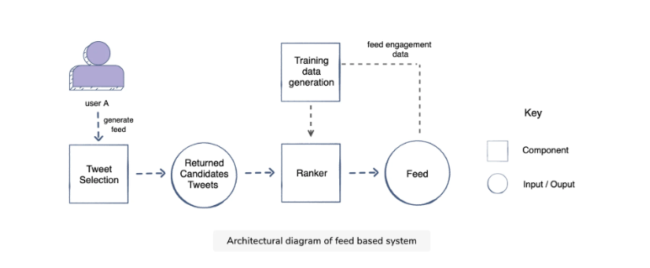

# Ranking Methods : Data Science Concepts

[**https://www.youtube.com/watch?v=yKwTAcsV8K8**](https://www.youtube.com/watch?v=yKwTAcsV8K8)

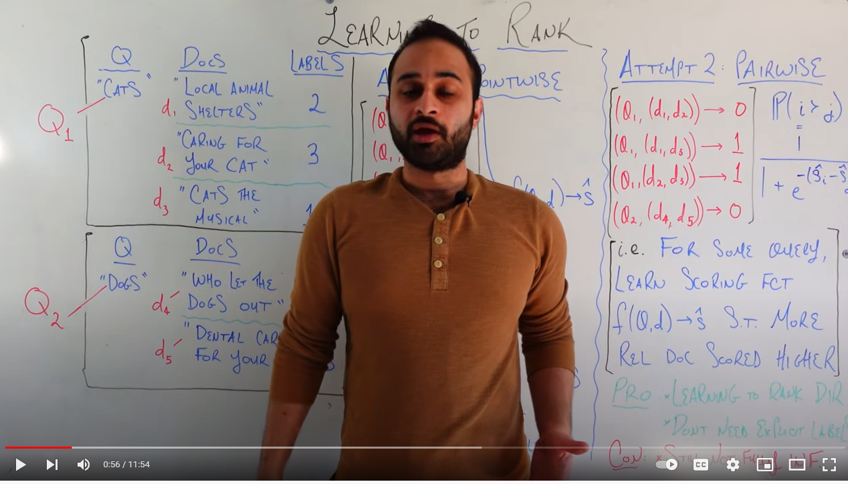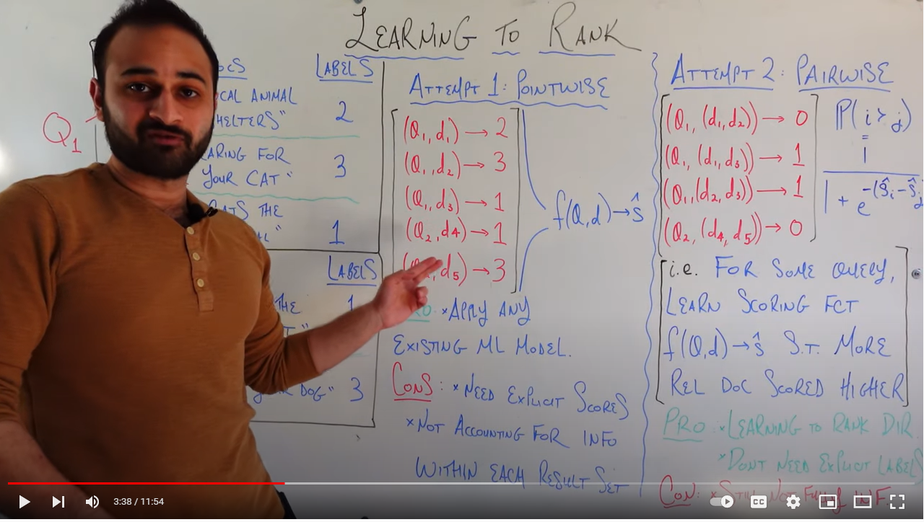

[**https://www.youtube.com/watch?v=ZxHo9WGn6KQ**](https://www.youtube.com/watch?v=ZxHo9WGn6KQ)

# ML System Design: Feature Store

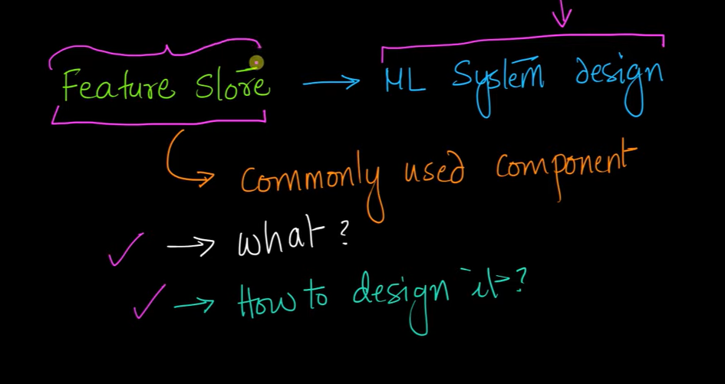

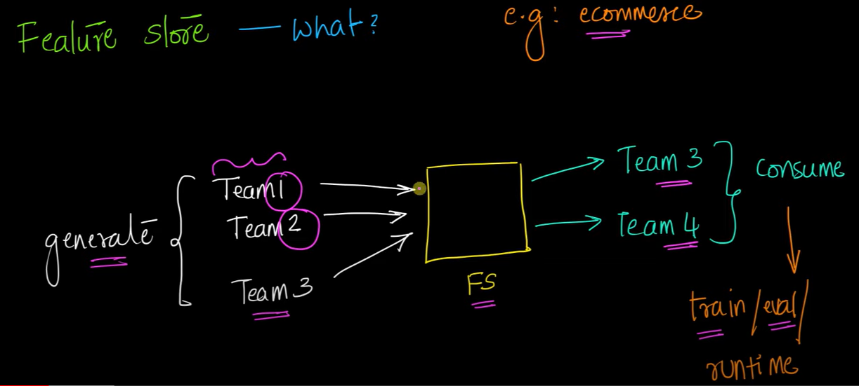

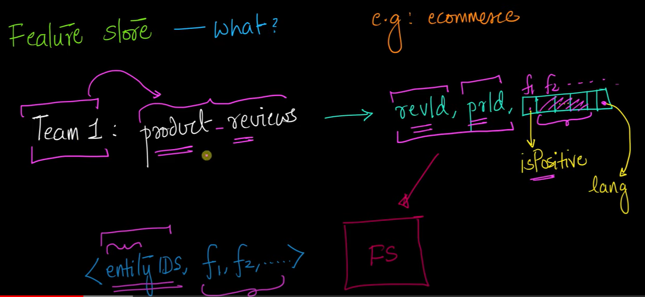

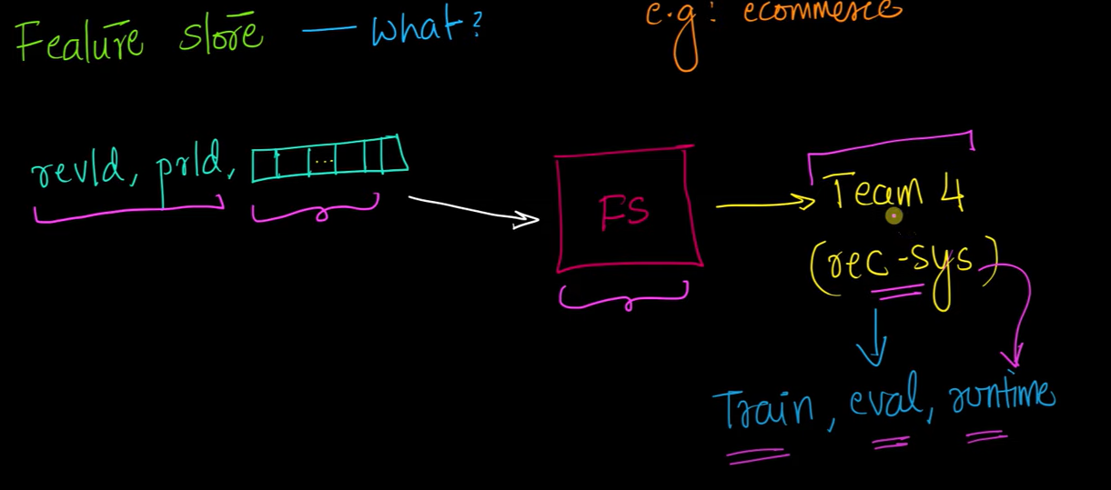

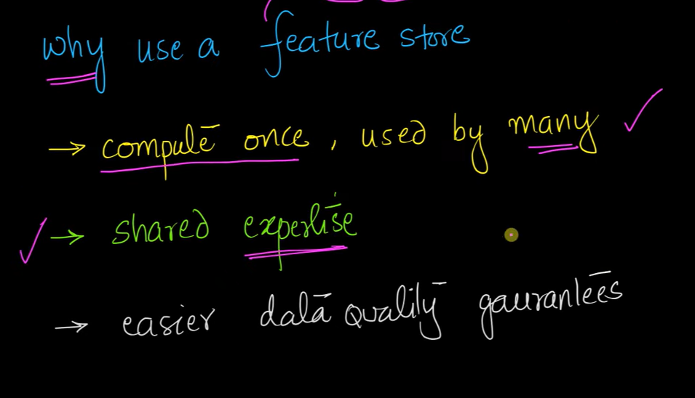

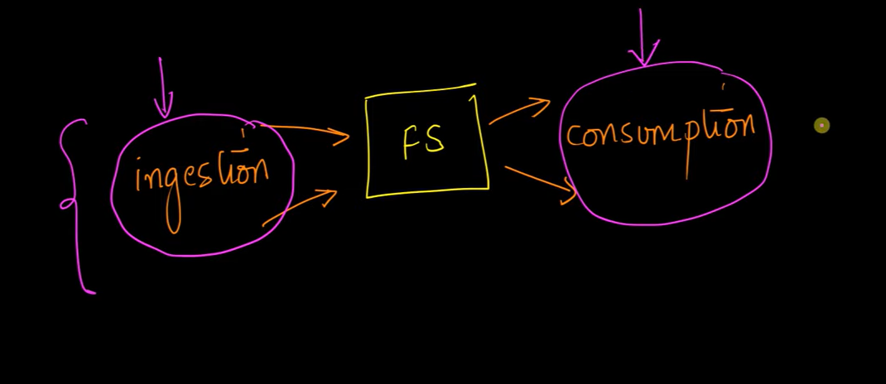

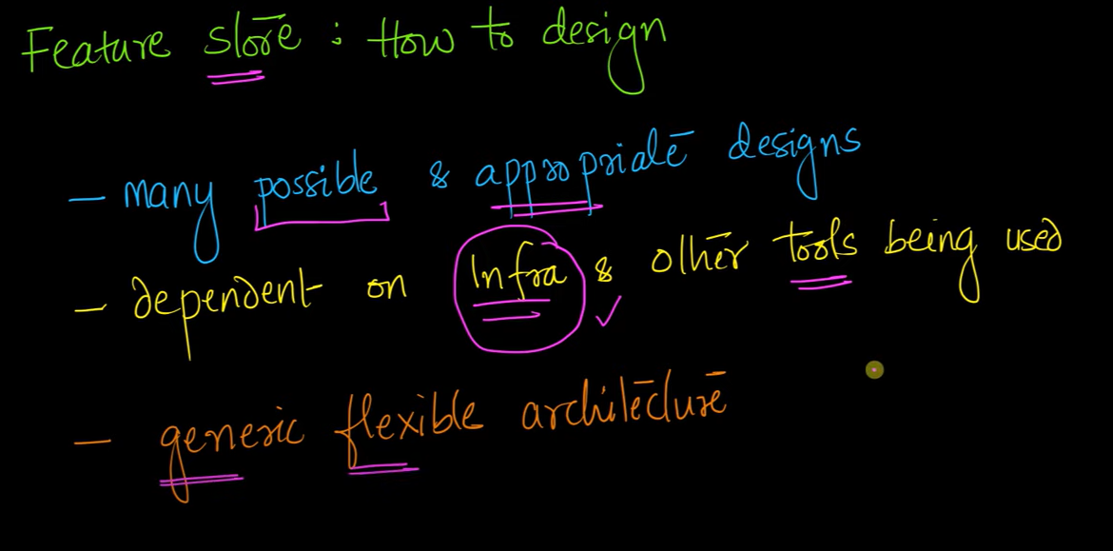

**Ingestion**

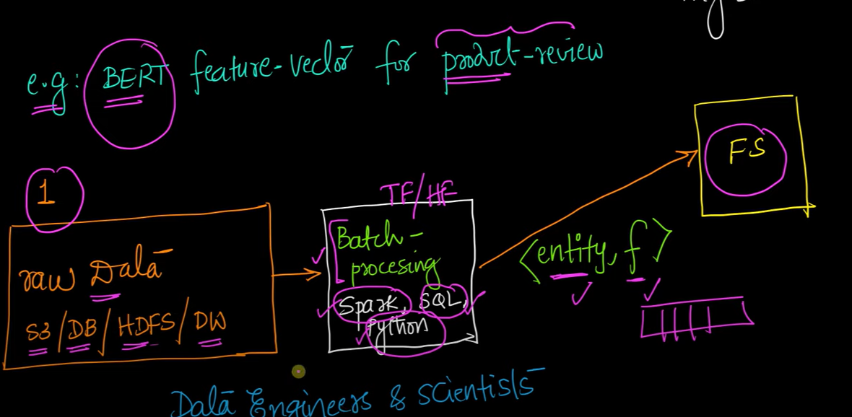

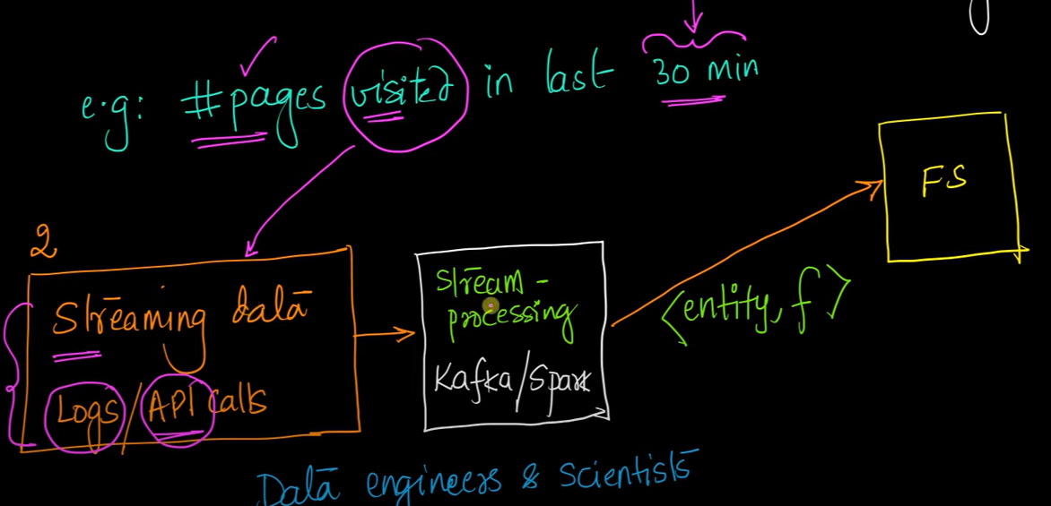

**Consumption**

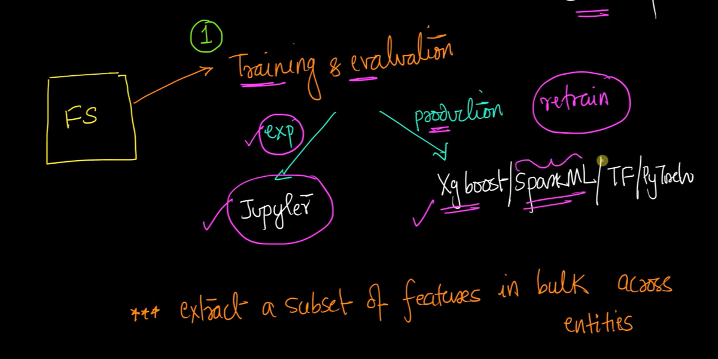

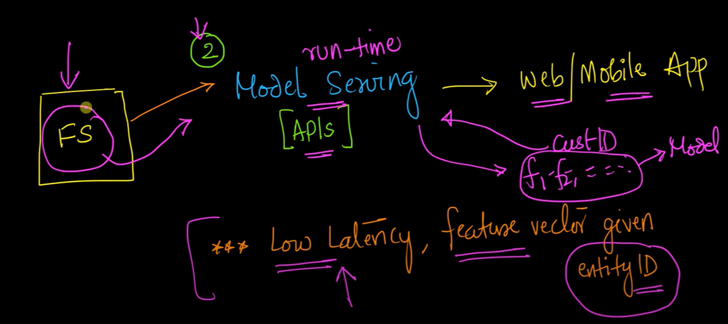

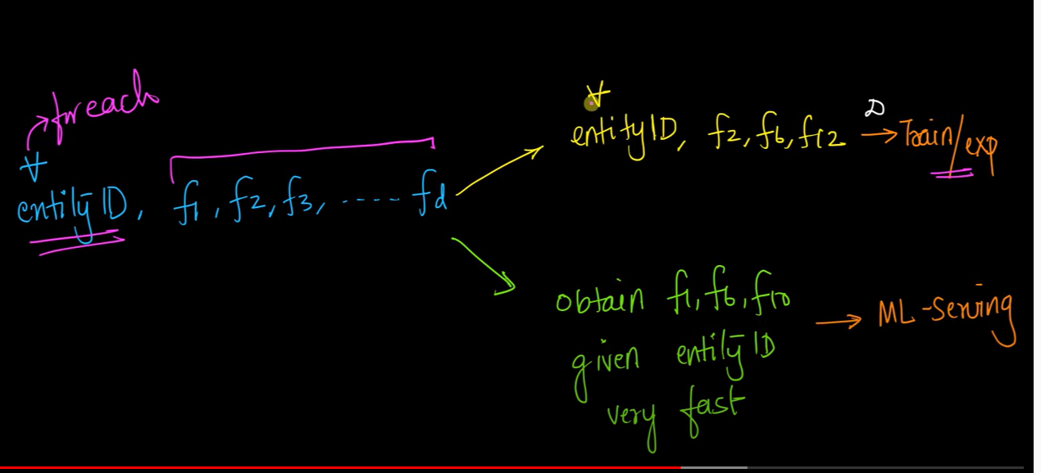

**You can use columnar store for Train/exp**

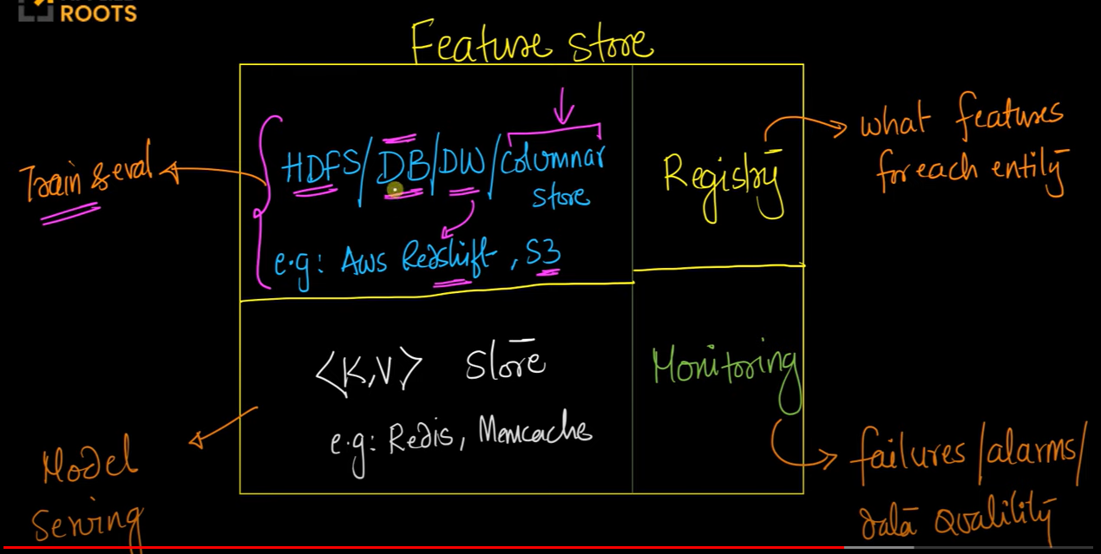

**Redis, Memcached 🡪 distribued hashmap**

**You are storing two copies of data**

**Registry = Metadata**

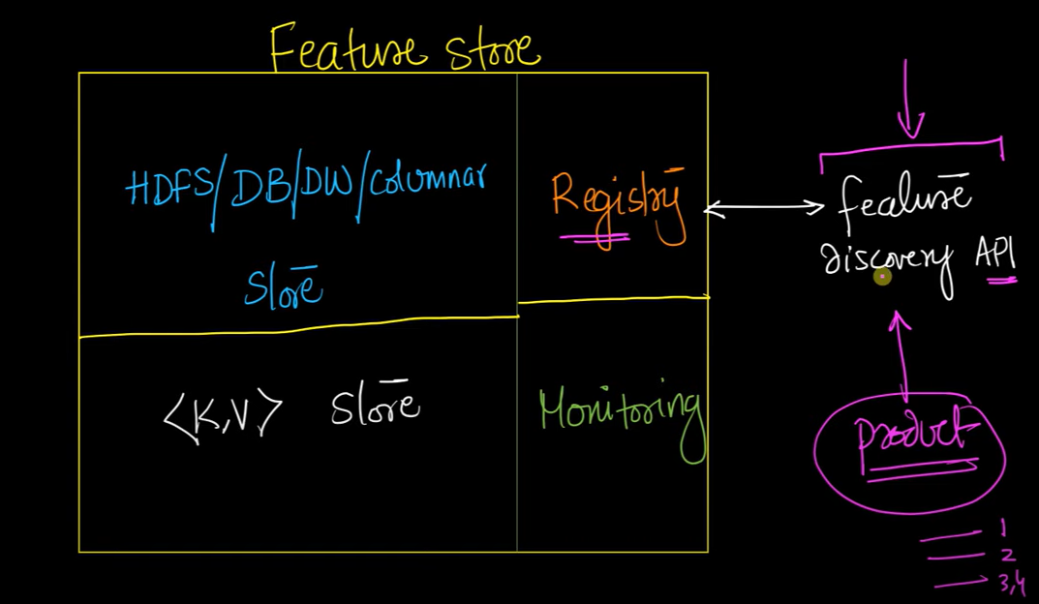

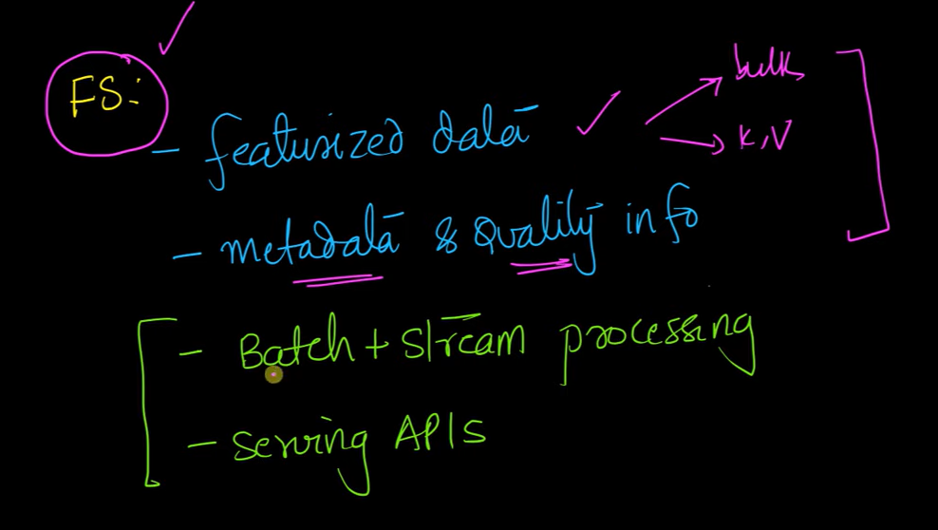

[**https://towardsdatascience.com/architecting-a-machine-learning-pipeline-a847f094d1c7**](https://towardsdatascience.com/architecting-a-machine-learning-pipeline-a847f094d1c7)

# ****Architecting a Machine Learning Pipeline****

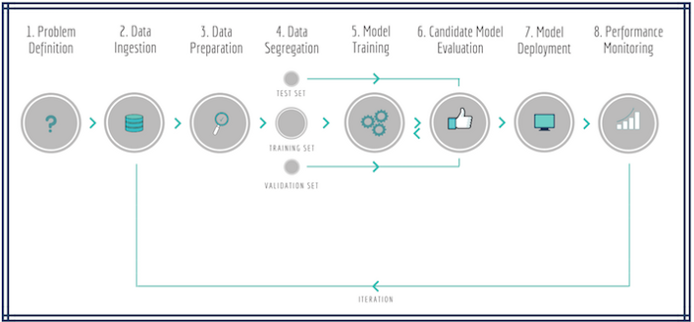

* **Online Model Analytics**: The top row represents the operational component of the application i.e. where the model is applied for **real-time** decision making.
* **Offline Data Discovery**: The bottom row represents the learning component i.e. analysis on historical data to create the ML model in a **batch-processing** mode.

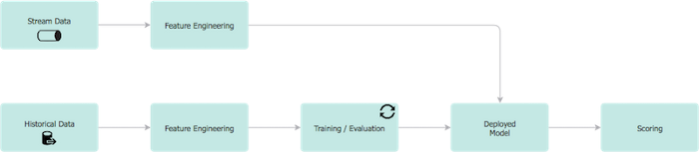

Selecting the features can be left to the caller, or can be automated e.g. apply a **chi-squared** statistical test to rank the impact of each feature on the concept label and discard the less impactful features prior to model training.

AUC is desirable for the following two reasons:

* AUC is **scale-invariant**. It measures how well predictions are ranked, rather than their absolute values.
* AUC is **classification-threshold-invariant**. It measures the quality of the model's predictions irrespective of what classification threshold is chosen.

In a multi-class model, we can plot the N number of AUC ROC Curves for N number classes using the One vs ALL methodology. So for example, If you have **three** classes named **X, Y,**and**Z**, you will have one ROC for X classified against Y and Z, another ROC for Y classified against X and Z, and the third one of Z classified against Y and X.

This is the worst situation. When AUC is approximately 0.5, the model has no discrimination capacity to distinguish between positive class and negative class.

from sklearn import metrics  
print(metrics.classification_report(y_test, y_pred))

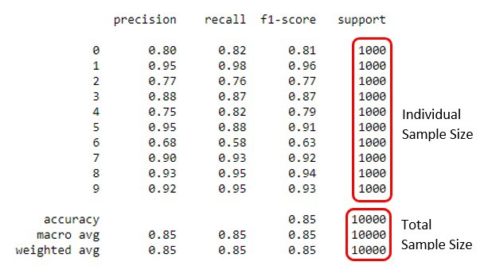

In the picture above, you can see that the support values are all 1000. That means the sample size for all the labels is 1000.

To illustrate why, take for example precision Pr=TP(TP+FP)Pr=TP(TP+FP). Let's imagine you have a *One-vs-All* (there is only one correct class output per example) multi-class classification system with four classes and the following numbers when tested:

* Class A: 1 TP and 1 FP
* Class B: 10 TP and 90 FP
* Class C: 1 TP and 1 FP
* Class D: 1 TP and 1 FP

You can see easily that PrA=PrC=PrD=0.5PrA=PrC=PrD=0.5, whereas PrB=0.1PrB=0.1.

* A macro-average will then compute: Pr=0.5+0.1+0.5+0.54=0.4Pr=0.5+0.1+0.5+0.54=0.4
* A micro-average will compute: Pr=1+10+1+12+100+2+2=0.123Pr=1+10+1+12+100+2+2=0.123

These are quite different values for precision. Intuitively, in the mac

Rewrite the code in the new language [i.e. translate from Python to CSharp]  
• Create custom DSL (Domain Specific Language) to describe the model  
• Microservice (accessed through a RESTful API)  
• API-first approach  
• Containerisation  
• Serialise the model and load into a in-memory key-value store

Model Scoring and Model Serving are two terms that are used interchangeably in the industry.

Any ML solution requires a well-defined performance monitoring solution. An example of information that we might want to see for model serving applications includes:  
• model identifier,  
• deployment date/time,  
• number of times the model has been served,  
• average/min/max model serving times,  
• distribution of features used.  
• predicted vs. actual/observed results.

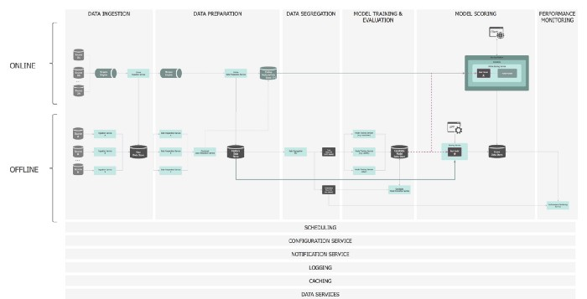

[**https://statisticsbyjim.com/regression/multicollinearity-in-regression-analysis/**](https://statisticsbyjim.com/regression/multicollinearity-in-regression-analysis/)

# Multicollinearity in Regression Analysis: Problems, Detection, and Solutions

However, when independent variables are correlated, it indicates that changes in one variable are associated with shifts in another variable.

* **Structural multicollinearity**: This type occurs when we create a model term using other terms. In other words, it’s a byproduct of the model that we specify rather than being present in the data itself. For example, if you square term X to model curvature, clearly there is a correlation between X and X2.
* **Data multicollinearity**: This type of multicollinearity is present in the data itself rather than being an artifact of our model. Observational experiments are more likely to exhibit this kind of multicollinearity.

Multicollinearity makes it hard to interpret your coefficients, and it reduces the power of your model to identify independent variables that are statistically significant. These are definitely serious problems. However, the good news is that you don’t always have to find a way to fix multicollinearity

Multicollinearity affects [the coefficients and p-values](https://statisticsbyjim.com/regression/interpret-coefficients-p-values-regression/), but it does not influence the predictions, precision of the predictions, and the goodness-of-fit [statistics](https://statisticsbyjim.com/glossary/statistics/).

## **Testing for Multicollinearity with Variance Inflation Factors (VIF)**

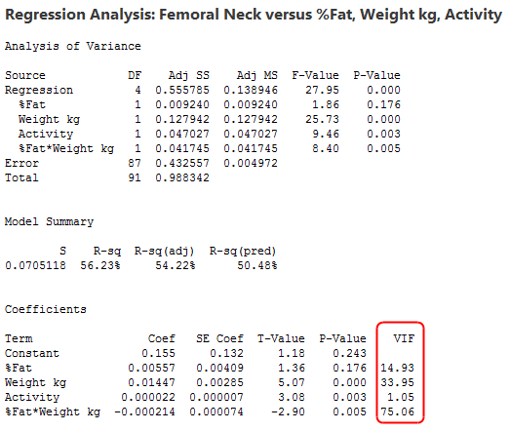

# P-value

By [Jim Frost](https://statisticsbyjim.com/author/statis11_wp/)

A [p-value](https://statisticsbyjim.com/glossary/p-value/) is the probability that you would obtain the [effect](https://statisticsbyjim.com/glossary/effect/) observed in your [sample](https://statisticsbyjim.com/glossary/sample/), or larger, if the null hypothesis is true for the populations. P-values are calculated based on your sample data and under the assumption that the null hypothesis is true. Lower p-values indicate greater evidence against the null hypothesis.

Use p-values during hypothesis testing to help you determine which hypothesis the data support. Compare your p-value to your [significance level](https://statisticsbyjim.com/glossary/significance-level/). If the p-value is less than your significance level, you can reject the null hypothesis and conclude that the effect is statistically significant. In other words, the evidence in your sample is strong enough to be able to reject the null hypothesis at the [population](https://statisticsbyjim.com/glossary/population/) level.

The potential solutions include the following:

* Remove some of the highly correlated independent variables.
* Linearly combine the independent variables, such as adding them together.
* Perform an analysis designed for highly correlated variables, such as principal components analysis or partial least squares regression.
* LASSO and Ridge regression are advanced forms of regression analysis that can handle multicollinearity. If you know how to perform [linear least squares](https://statisticsbyjim.com/glossary/ordinary-least-squares/) regression, you’ll be able to handle these analyses with just a little additional study.

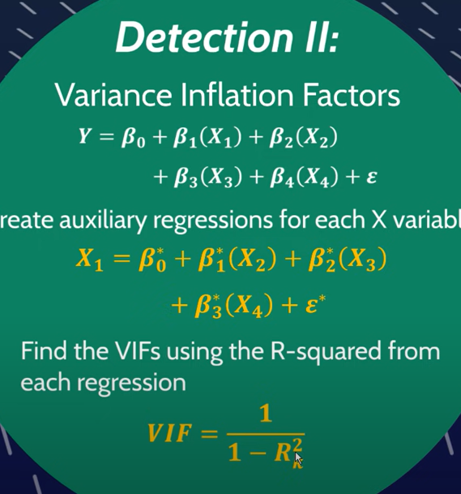

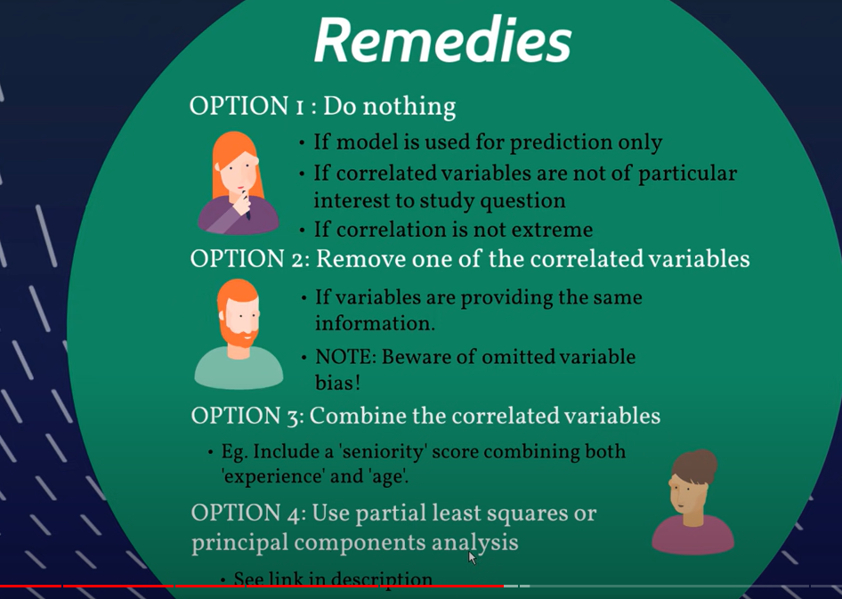

[**https://sebastianraschka.com/Articles/2014_about_feature_scaling.html**](https://sebastianraschka.com/Articles/2014_about_feature_scaling.html)

# About Feature Scaling and Normalization

Some examples of algorithms where feature scaling matters are:

* k-nearest neighbors with an Euclidean distance measure if want all features to contribute equally
* k-means (see k-nearest neighbors)
* logistic regression, SVMs, perceptrons, neural networks etc. if you are using gradient descent/ascent-based optimization, otherwise some weights will update much faster than others
* linear discriminant analysis, principal component analysis, kernel principal component analysis since you want to find directions of maximizing the variance (under the constraints that those directions/eigenvectors/principal components are orthogonal); you want to have features on the same scale since you’d emphasize variables on “larger measurement scales” more. There are many more cases than I can possibly list here … I always recommend you to think about the algorithm and what it’s doing, and then it typically becomes obvious whether we want to scale your features or not.
* A Min-Max scaling is typically done via the following equation:
* Xnorm=X−XminXmax−Xmin

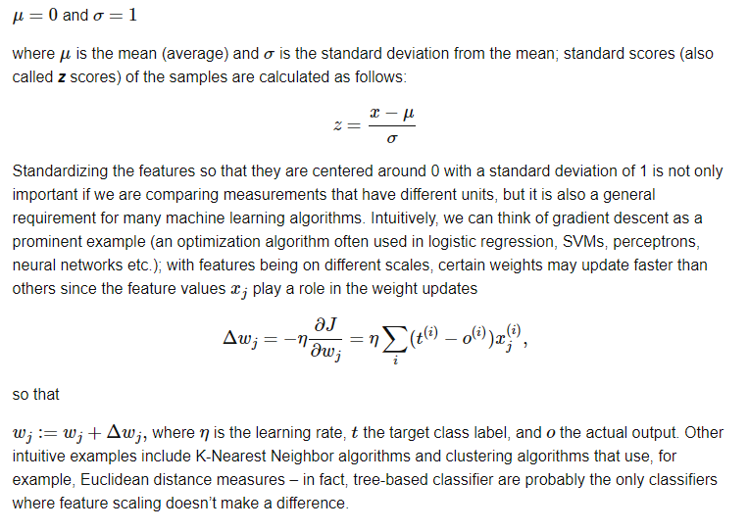

from sklearn import preprocessing

std_scale **=** preprocessing.StandardScaler().fit(df[['Alcohol', 'Malic acid']])

df_std **=** std_scale.transform(df[['Alcohol', 'Malic acid']])

minmax_scale **=** preprocessing.MinMaxScaler().fit(df[['Alcohol', 'Malic acid']])

df_minmax **=** minmax_scale.transform(df[['Alcohol', 'Malic acid']])

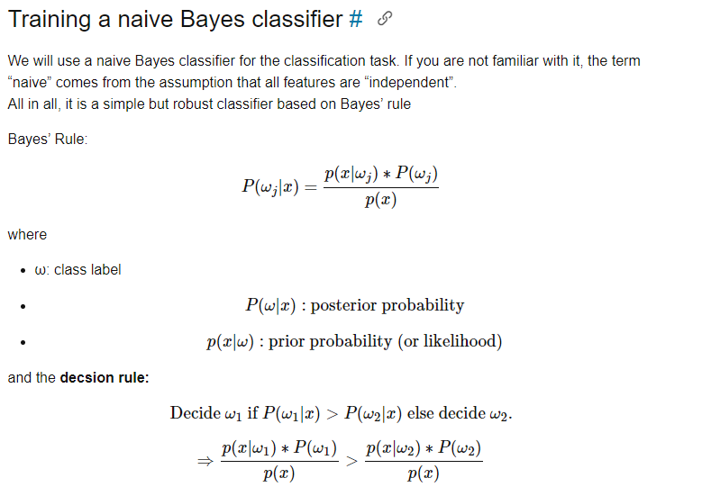

### **1. Mean centering does not affect the covariance matrix**

# Gradient Boosting vs Random Forest

 The trained ensemble, therefore, represents a single hypothesis. Empirically, ensembles tend to yield better results when there is a significant diversity among the models. Many ensemble methods, therefore, seek to promote diversity among the models they combine

<https://medium.com/@aravanshad/ensemble-methods-95533944783f>

Common types of ensembles

Simple averaging: One of the most popular ways of combining multiple hypotheses is through simply averaging of the corresponding output values. It is considered a too simple but very effective ensemble method. It achieves most of the benefits of ensembles in reducing the variance of the estimate of the output class posteriors.

Bootstrap Aggregating (Bagging): This algorithm generates multiple bootstrap training sets from the original training set and uses each of them to generate a classifier for inclusion in the ensemble. In general, bagging does more to reduce the variance in the base models than the bias, so bagging performs best relative to its base models when the base models have high variance and low bias.

Stacking (stacked generalization): The main concept is to use a new classifier to correct the errors of a previous classifier, hence the classifier are stacked on top of one another. It involves training a learning algorithm to combine the predictions of several other learning algorithms.

Boosting: This algorithm involves incrementally building an ensemble by training each new model instance to emphasize the training instances that previous models mis-classified. Boosting does more to reduce bias than variance.

*Advantages of ensemble methods*

* Intuitively, ensembles allow the different needs of a difficult problem to be handled by hypotheses suited to those particular needs.
* Mathematically, ensembles provide an extra degree of freedom in the classical bias/variance tradeoff, allowing solutions that would be difficult (if not impossible) to reach with only a single hypothesis.
* They’re unlikely to overfit.

*Disadvantages of ensemble methods*

* The model that is closest to the true data generating process will always be best and will beat most ensemble methods. So if the data come from a linear process, linear models will be much superior to ensemble models.
* Ensemble models suffer from lack of interpretability. Sometimes we need predictions and explanations of the predictions. It is hard to convince people to act on predictions when the methods are too complex for their comfort level. Variable importance analysis can help with insights, but if the ensemble is more accurate than a linear additive model, the ensemble is probably exploiting some non-linear and interaction effects that the variable importance analysis can’t completely account for [3].
* Ensemble methods are usually computationally expensive. Therefore, they add learning time and memory constrains to the problem.

**Random Forest:** RFs train each tree independently, using a random sample of the data. This randomness helps to make the model more robust than a single decision tree, and less likely to overfit on the training data [1,2].

**Gradient Boosting:** GBT build trees one at a time, where each new tree helps to correct errors made by previously trained tree.

[**http://alexhwilliams.info/itsneuronalblog/2016/03/27/pca/**](http://alexhwilliams.info/itsneuronalblog/2016/03/27/pca/)

# Everything you did and didn't know about PCA

Principle components analysis (PCA) is a standard way to reduce the dimension p (which can be quite large) to something more manageable.

There are a few ways to solve this optimization problem to determine c and w. The classic approach would be to compute the eigenvalues of XTX (the [covariance matrix](https://en.wikipedia.org/wiki/Covariance_matrix) with dimensions p×p) and set c to the eigenvector associated with the largest eigenvalue.[[2]](http://alexhwilliams.info/itsneuronalblog/2016/03/27/pca/#f2b) This is more-or-less what happens under the hood when you call pca() in MATLAB or python — the eigendecomposition of the covariance matrix is computed via the [singular value decomposition (SVD)](https://en.wikipedia.org/wiki/Singular_value_decomposition).

[**https://www.linkedin.com/pulse/intuitive-visual-explanation-differences-between-l1-l2-xiaoli-chen/**](https://www.linkedin.com/pulse/intuitive-visual-explanation-differences-between-l1-l2-xiaoli-chen/)

# Intuitive and Visual Explanation on the differences between L1 and L2 regularization

We chose to avoid manipulating single coefficients, but to give a quota for all these coefficients, and give them more freedom and flexibility to pick up the most influential factors, and to eliminate the least ones.

That is the intuition of regularization.

Regularization removes extra weights from the selected features and redistributes the weights evenly. This means that regularization discourages the learning of a model of both high complexity and flexibility. A highly flexible model is one that possesses the freedom to fit as many data points as possible.

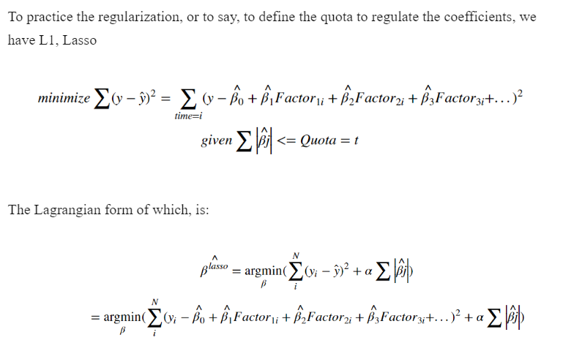

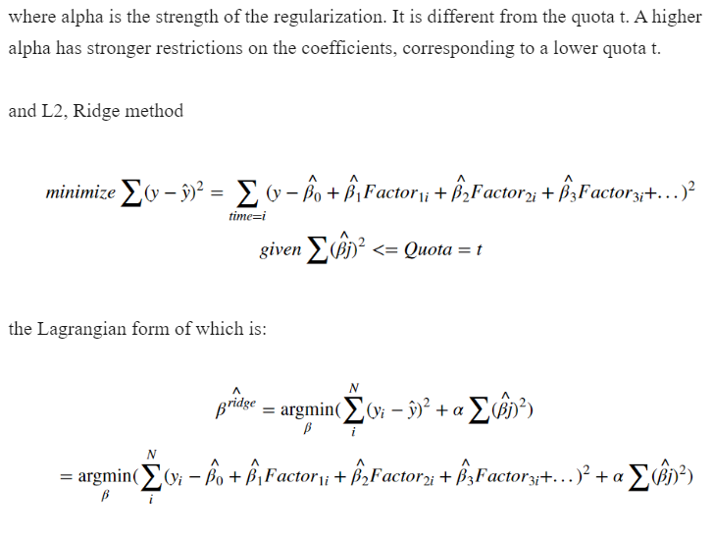

***The difference is that****: while shrinking the quota,****L1 tends to cut off some factors by turning their coefficients to zero****, while L2 tend****s to shrinking these coefficients to a tiny number (none zero)****, keep some of their influence on Y.*

The alpha term is regularization strength. Larger alpha value means stronger restriction on coefficients, with more factors' coefficients shrinking to tiny number.

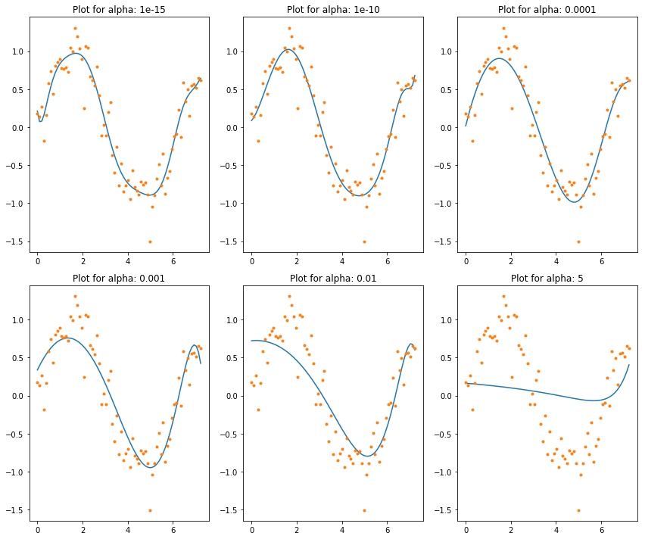

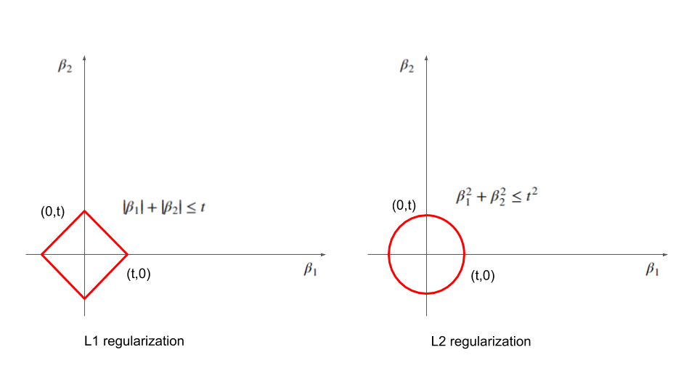

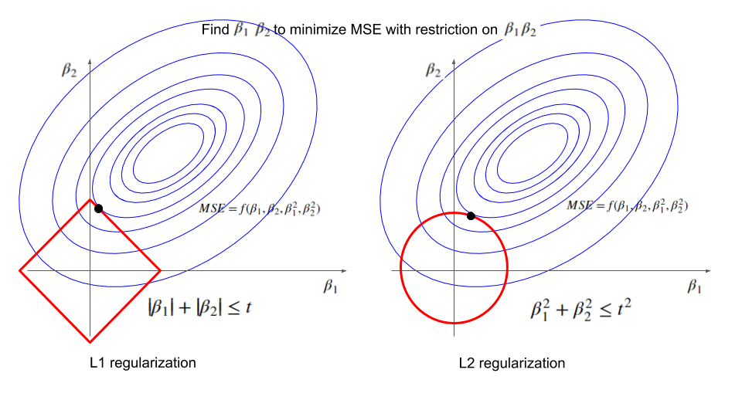

**Flashcards**

**AIC is most frequently used in situations where one is not able to easily test the model’s performance on a test set in standard machine learning practice (small data, or time series)**. AIC is particularly valuable for time series, because time series analysis’ most valuable data is often the most recent, which is stuck in the validation and test sets.

## **What is Ridge Regression?**

Ridge [regression](https://www.mygreatlearning.com/blog/what-is-regression/) is a model tuning method that is used to analyse any data that suffers from multicollinearity. This method performs L2 regularization. When the issue of multicollinearity occurs, least-squares are unbiased, and variances are large, this results in predicted values being far away from the actual value

The cost function for ridge regression:

***Min(||Y – X(theta)||^2 + λ||theta||^2)***

Lambda is the penalty term. λ given here is denoted by an alpha parameter in the ridge function. So, by changing the values of alpha, we are controlling the penalty term. The higher the values of alpha, the bigger is the penalty and therefore the magnitude of coefficients is reduced.

* It shrinks the parameters. Therefore, it is used to prevent multicollinearity
* It reduces the model complexity by coefficient shrinkage

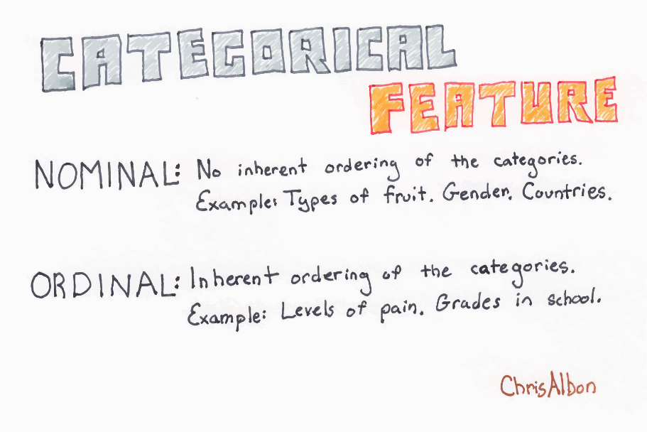

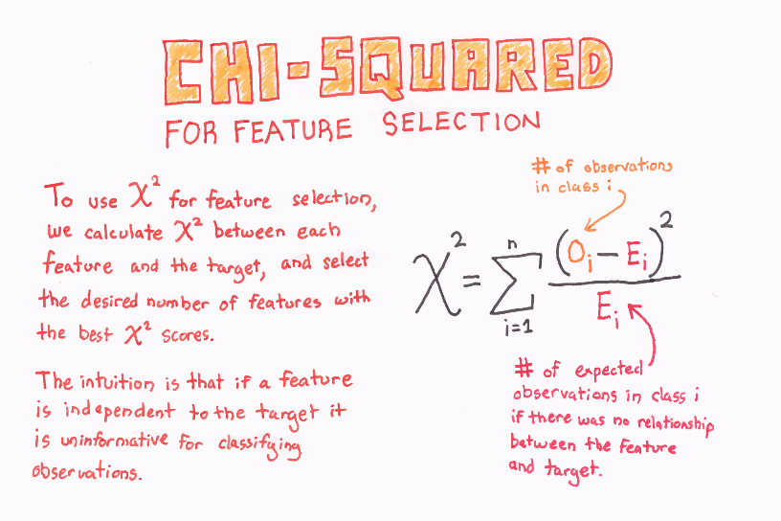

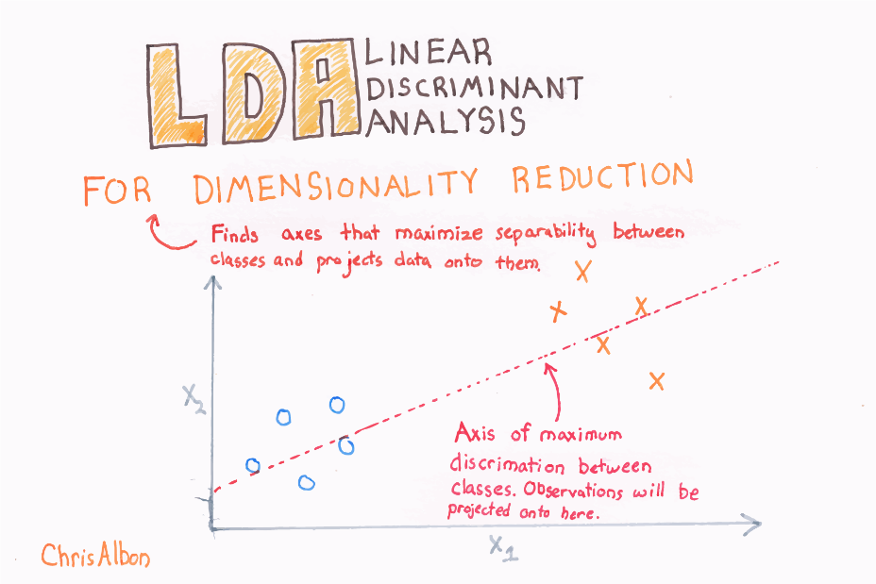

**Linear Discriminant Analysis** or **Normal Discriminant Analysis** or **Discriminant Function Analysis** is a dimensionality reduction technique that is commonly used for supervised classification problems. It is used for modelling differences in groups i.e. separating two or more classes. It is used to project the features in higher dimension space into a lower dimension space.

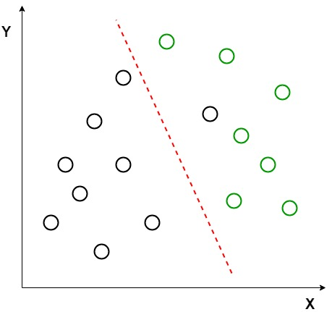

Here, Linear Discriminant Analysis uses both the axes (X and Y) to create a new axis and projects data onto a new axis in a way to maximize the separation of the two categories and hence, reducing the 2D graph into a 1D graph. 

Two criteria are used by LDA to create a new axis:

1. Maximize the distance between means of the two classes.
2. Minimize the variation within each class.
3. LDA is a generalized form of FLD. Fisher in his paper used a discriminant function to classify between two plant species *Iris Setosa* and *Iris Versicolor.*
4. *The basic idea of FLD is to project data points onto a line to maximize the between-class scatter and minimize the within-class scatter.*

**Statitistics and Probablity for Data Science**

[**https://www.analyticsvidhya.com/blog/2021/04/statistics-and-probability-concepts-for-data-science/#:~:text=It%20means%20how%20likely%20an,the%20occurrence%20of%20an%20event.&text=for%20probability%20is%3A-,For%20example%3A,when%20it's%20flipped%20is%200.5**](https://www.analyticsvidhya.com/blog/2021/04/statistics-and-probability-concepts-for-data-science/#:~:text=It%20means%20how%20likely%20an,the%20occurrence%20of%20an%20event.&text=for%20probability%20is%3A-,For%20example%3A,when%20it's%20flipped%20is%200.5)**.**

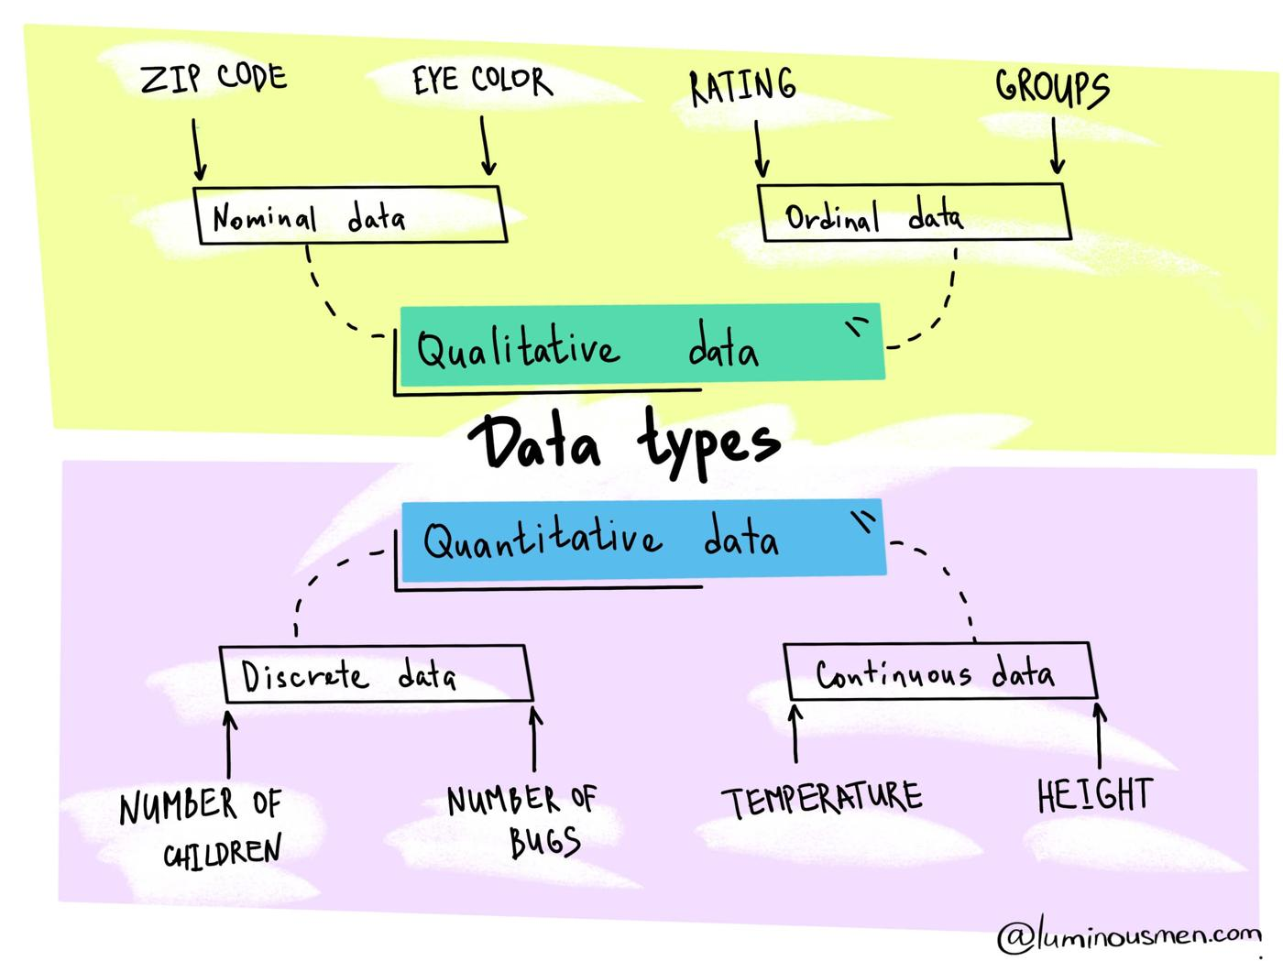

Mathematically and statistically, ***variance*** is defined as the average of the squared differences from the mean. But for understanding, this depicts how **spread out** the data is in a dataset.

In data science, the standard deviation is usually used to identify the outliers in a data set. The data points which lie one standard deviation away from the mean are considered to be unusual.

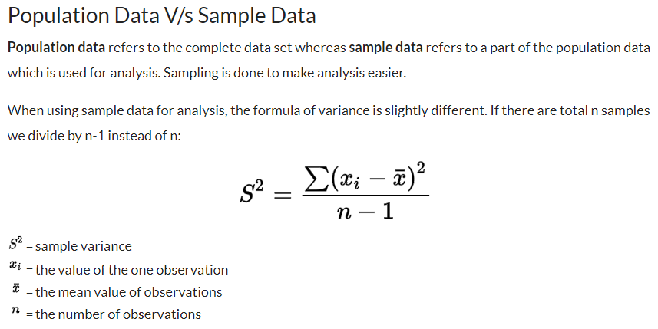

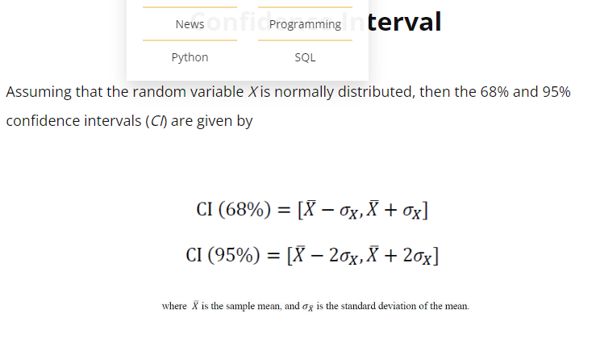

[**https://www.kdnuggets.com/2022/06/statistics-probability-data-science.html**](https://www.kdnuggets.com/2022/06/statistics-probability-data-science.html)

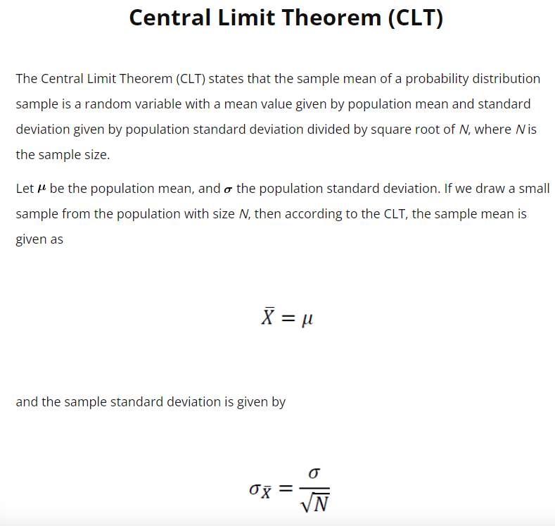

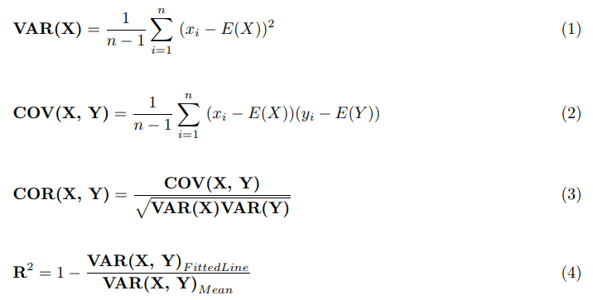

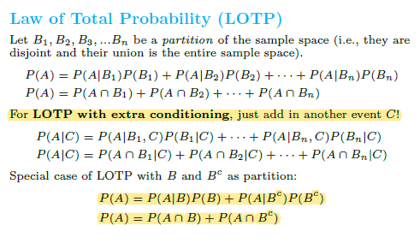

**Probability mass function**

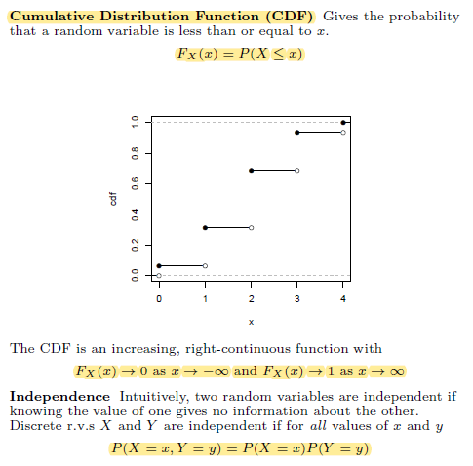

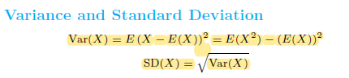

***“Skewness essentially measures the symmetry of the distribution, while kurtosis determines the heaviness of the distribution tails.”***

*In statistics, skewness is a degree of asymmetry observed in a probability distribution that deviates from the symmetrical normal distribution (bell  
curve) in a given set of data.*

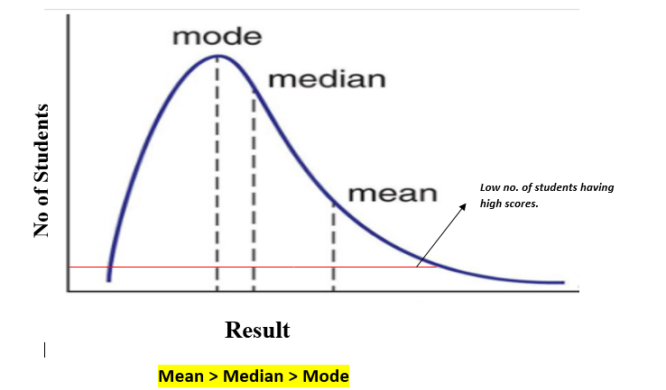

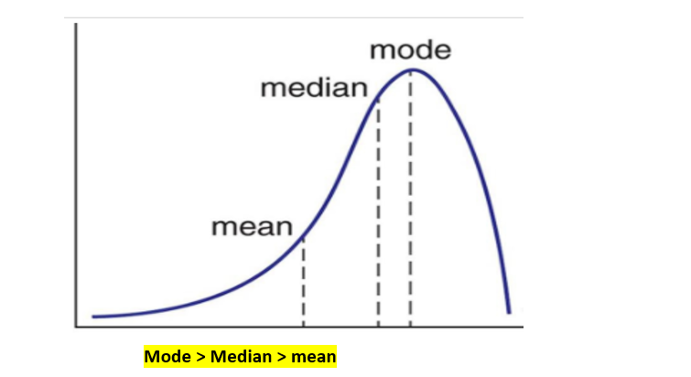

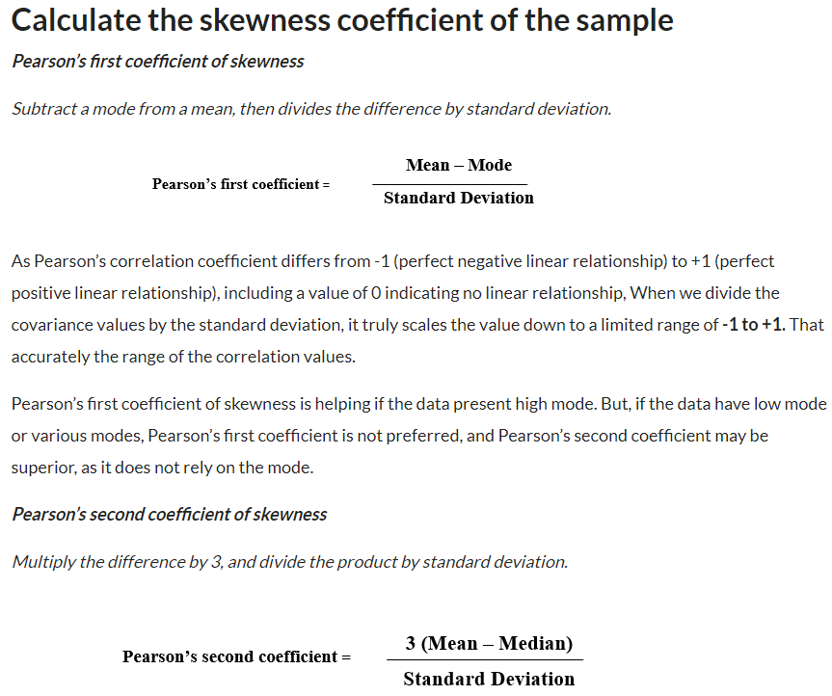

[**https://www.analyticsvidhya.com/blog/2021/05/shape-of-data-skewness-and-kurtosis/**](https://www.analyticsvidhya.com/blog/2021/05/shape-of-data-skewness-and-kurtosis/)

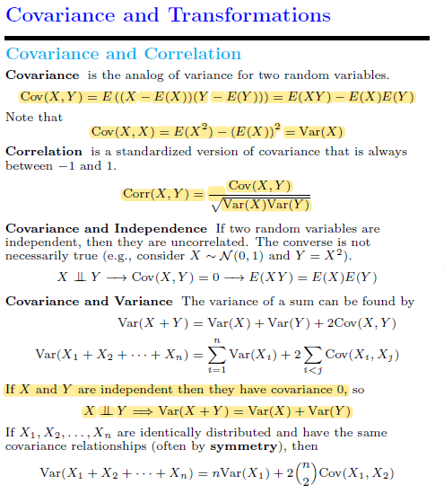

## **Introduction to Probability Distributions**

Simply put, the probability distribution is a way to represent possible values a variable may take and their respective probability.

#### **Discrete**

* Bernoulli Distribution
* Binomial Distribution
* Poisson Distribution

#### **Continuous**

* Normal Distribution
* chi2 Distribution
* Student-t Distribution
* Log-Normal Distribution
* Exponential Distribution

[**https://towardsdatascience.com/probability-distributions-to-be-aware-of-for-data-science-with-code-c4a6bb8b0e9a**](https://towardsdatascience.com/probability-distributions-to-be-aware-of-for-data-science-with-code-c4a6bb8b0e9a)

# Uniform Distribution

# Gaussian distribution

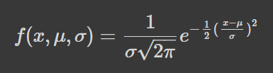

 But it’s important to note that in a normal distribution, the mean, mode, and median are all equal.

* 68% of the data falls within one standard deviation of the mean.
* 95% of the data falls within two standard deviations of the mean.
* 99.7% of the data falls within three standard deviations of the mean.

# Lognormal distribution

*A lognormal distribution is a continuous probability distribution of a random variable whose logarithm is normally distributed. Thus, if the random variable*X*is log-normally distributed, then*Y*= ln(*X*) has a normal distribution .*

# Poisson distribution

It’s a discrete probability distribution which means it counts occurrences that have finite outcomes — in other words, it’s a count distribution. Thus, the Poisson distribution is used to show the number of times an event is likely to occur over a specified period.d

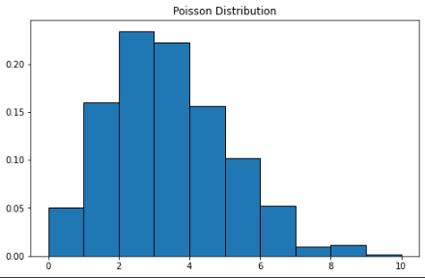

# Exponential distribution

*The exponential distribution is the probability distribution of the time between events in a Poisson point process.*

# Binomial distribution

You can think of the binomial distribution as the probability of success or failure in an experiment. Some may also describe it as the coin toss probability. *the binomial distribution with parameters n and p is the discrete probability distribution of the number of successes in a sequence of n independent experiments, each asking a yes–no question, and each with its own Boolean-valued outcome: success or failure.*

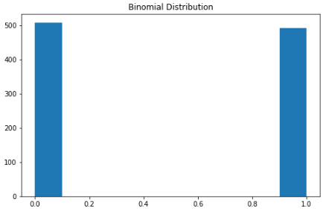

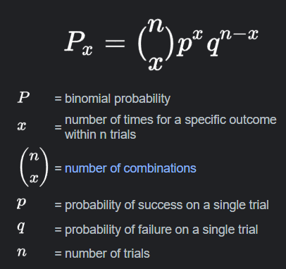

# Chi-squared distribution

The chi-squared distribution is a special case of the gamma distribution; With **k**degrees of freedom, the chi-squared distribution is the sum of the squares of **k** for some independent standard normal random variables.

**ML Production/Deploy**

<https://www.qwak.com/post/what-does-it-take-to-deploy-ml-models-in-production>

Deployment is the process by which a ML model is moved from an offline environment and integrated into an existing production environment, such as a live application. It is a critical step that must be completed in order for a model to serve its intended purpose and solve the challenges it is designed for.

Consider questions like:

* How is your data stored?
* How large is your data?
* How will you retrieve your data?
* **Storage:**It makes sense to store your data where model training will take place and where results will be served. Data can be stored either on-premises, in the cloud, or in a hybrid environment, with cloud storage generally used for cloud ML training and serving.
* ‍
* **Size:**The size of your data is also important. Larger datasets require more computing power for processing and model optimization. If you are working in a cloud environment, then this means that you will need to factor in cloud scaling from the start, and this can get very expensive if you haven’t thoroughly pre-planned and thought through your needs.
* ‍
* **Retrieval:**How you will retrieve your data (i.e., batch vs real-time) must be considered before designing your ML model.

### How you’ll collect feedback

Machine learning projects are dynamic and constantly evolving. Feedback and iteration form important parts of development and deployment processes, and you must consider these from the outset.

‍

Consider questions like:

* How can we retrieve feedback from production models?
* How can we ensure constant delivery?
* How can we test new iterations of the model?
* How can we iterate our model without interrupting its operation?

## How to deploy ML models

As we alluded to above, the general ML model deployment process can be summarised in four key steps:

### 1. Develop and create a model in a training environment

To deploy a machine learning application, you first need to build your model.

‍

ML teams tend to create several ML models for a single project, with only a few of these making it through to the deployment phase. These models will usually be built in an offline training environment, either through a supervised or unsupervised process, where they are fed with training data as part of the development process.

### 2. Optimize and test code, then clean and test again

When a model has been built, the next step is to check that the code is of a good enough quality to be deployed. If it isn’t, then it is important to clean and optimize it before re-testing. And this should be repeated where necessary.

‍

Doing so not only ensures that the ML model will function in a live environment but also gives others in the organization the opportunity to understand how the model was built. This is important because ML teams do not work in isolation; others will need to look at, scrutinize, and streamline the code as part of the development process. Therefore, accurately explaining the model’s production process and any results is a key part of the process.

### 3. Prepare for container deployment

Containerization is an important tool for ML deployment, and ML teams should put their models into a container before deployment. This is because containers are predictable, repetitive, immutable, and easy to coordinate; they are the perfect environment for deployment.

‍

Over the years, containers have become highly popular for ML model deployment because they simplify deployment and scaling. ML models that are containerized are also easy to modify and update, which mitigates the risk of downtime and makes model maintenance less challenging.

### 4. Plan for continuous monitoring and maintenance

The key to successful ML model deployment is ongoing monitoring, maintenance, and governance. Merely ensuring that the model is initially working in a live setting is not enough; continuous monitoring helps to ensure that the model will be effective for the long term.

‍

Beyond ML model development, it is important for ML teams to establish processes for effective monitoring and optimization so that models can be kept in the best condition. Once continuous monitoring processes have been planned and implemented, issues like data drift, inefficiencies, and bias can be detected and rectified. Depending on the ML model, it may also be possible to regularly retrain it with new data to avoid the model drifting too far away from the live data.

## Making ML model deployment more efficient

What if we told you that deploying your ML models could be as easy as following three simple steps? It’s true! Here are our tips for deploying your own model and avoiding many of the challenges at the same time:

### 1. Decide on a deployment method

The first step is to figure out which deployment method you want to use. There are two main ones: batch inference and online inference.

‍

**Batch inference:**This method runs periodically and provides results for the batch of new data generated since the previous run. It generates answers with latency and is therefore useful where model results are not needed immediately or in real-time. The main benefit of batch inference is the ability to deploy more complex models.

‍

**Online inference:**Also known as real-time inference, this method provides results in real-time. While this sounds like the better method, it has an inherent latency constraint that limits the type of ML models that can be deployed using it. Since results are provided in real-time, it is not possible to deploy complex models with online inference.

‍

When deciding which method to use, consider questions like:

* How often do we need our model to generate predictions?
* Should model results be based on batch data or individual cases?
* How much computational power can we allocate?
* How complex is our model?

<https://towardsdatascience.com/how-to-easily-deploy-machine-learning-models-using-flask-b95af8fe34d4>

# Project Structure

This project has four parts :

1. model.py — This contains code for the machine learning model to predict sales in the third month based on the sales in the first two months.
2. app.py — This contains Flask APIs that receives sales details through GUI or API calls, computes the predicted value based on our model and returns it.
3. request.py — This uses requests module to call APIs defined in app.py and displays the returned value.
4. HTML/CSS — This contains the HTML template and CSS styling to allow user to enter sales detail and displays the predicted sales in the third month.

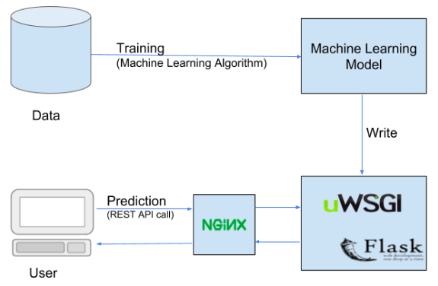

# Serializing/De-Serializing

In simple words serializing is a way to write a python object on the disk that can be transferred anywhere and later de-serialized (read) back by a python script.

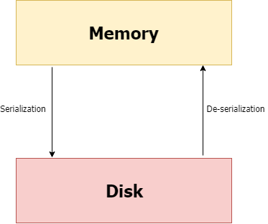

 I set the main page using index.html. On submitting the form values using POST request to /predict, we get the predicted sales value.

The results can be shown by making another POST request to /results. It receives JSON inputs, uses the trained model to make a prediction and returns that prediction in JSON format which can be accessed through the API endpoint.

# Cyclical Learning Rates

[**https://medium.com/swlh/cyclical-learning-rates-the-ultimate-guide-for-setting-learning-rates-for-neural-networks-3104e906f0ae**](https://medium.com/swlh/cyclical-learning-rates-the-ultimate-guide-for-setting-learning-rates-for-neural-networks-3104e906f0ae)

new_weight = current_weight - learning_rate * gradient

# What is Cyclical Learning Rate?

*A technique to set and change and tweak*LR*during training.*

This methodology aims to train neural network with a LR that changes in a cyclical way for each batch, instead of a non-cyclic LR that is either constant or changes on every epoch. The learning rate schedule varies between two bounds.

**When using a cyclical LR, we have to calculate two things**:  
1) The bounds between which the learning rate will vary — **base_lr** and **max_lr**.  
2) The step_size — in how many epochs the learning rate will reach from one bound to the other.

## Why it works?

We have always learnt that we should keep decreasing LR as training progresses so that we converge with time.

In CLR, we vary the LR between a lower and higher threshold. The logic is that periodic higher learning rates within each epoch helps to come out of any [saddle points](https://datascience.stackexchange.com/questions/22853/local-minima-vs-saddle-points-in-deep-learning) or l[ocal minima](https://datascience.stackexchange.com/questions/22853/local-minima-vs-saddle-points-in-deep-learning) if it encounters into one. If saddle point happens to be an elaborated plateau, lower learning rates will probably never generate enough gradient to come out of it, resulting in difficulty in minimising the loss.

## Objective

Pick a learning rate and change it on each iteration(batch) to make the training process performant — which means -:

1. Achieve the maximum possible accuracy in order to get best prediction results.
2. Speed up the training process by achieving above in minimum number of epochs .

**Cycle**Number of iterations we want for our learning rate to go from lower bound to upper bound, and then back to lower bound.

# Variations of CLR

Other than triangular profile used above, Lesley Smith also suggested some other forms of CLR.

**Triangular2 :**Here the max_lr is halved after every cycle.

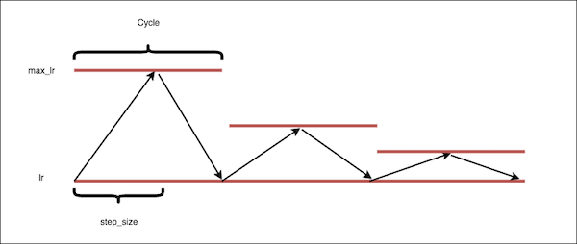

**Exponential Range :**Here max_lr is reduced exponentially with each iteration.

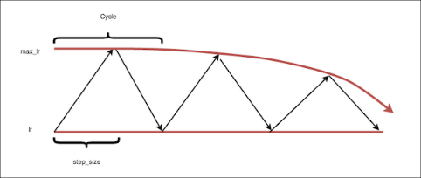

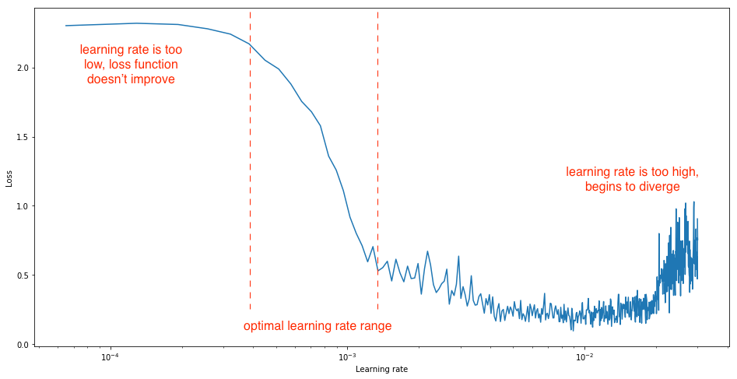

Bessels’ correction refers to the “n-1” found in several formulas, including the [sample variance](https://www.statisticshowto.com/probability-and-statistics/descriptive-statistics/sample-variance/) and sample [standard deviation](https://www.statisticshowto.com/probability-and-statistics/standard-deviation/) formulas. This correction is made to correct for the fact that these sample [statistics](https://www.statisticshowto.com/statistic/)tend to underestimate the actual [parameters](https://www.statisticshowto.com/what-is-a-parameter-statisticshowto/)found in the population. **The simple answer:** the calculations for both the sample standard deviation and the sample variance both contain a little [bias](https://www.statisticshowto.com/what-is-bias/)(that’s the statistics way of saying “error”). Bessel’s correction (i.e. subtracting 1 from your sample size) corrects this bias. In other words, **you’ll usually get a more accurate answer if you use n-1 instead of n.**

Translational Invariance makes the CNN invariant to translation. Invariance to translation means that if we translate the inputs the CNN will still be able to detect the class to which the input belongs.

## **TRANSLATIONAL EQUIVARIANCE:**

Translational Equivariance or just equivariance is a very important property of the convolutional neural networks where the position of the object in the image should not be fixed in order for it to be detected by the CNN. This simply means that if the input changes, the output also changes. To be precise, a function f(x) is said to be equivariant to a function g if f(g(x)) = g(f(x)). If we have a function g which shifts each pixel of the image, one pixel to the right i.e I’(x,y) = I(x-1,y). If we apply the transformation g on the image and then apply convolution, the result will be the same as if we applied convolution to I’ and then applied translation g to the output. When processing images, this simply means that if we move the input 1 pixel to the right then it’s representations will also move 1 pixel to the right.  
The property of translational equivariance is achieved in CNN’s by the concept of weight sharing. As the same weights are shared across the images, hence if an object occurs in any image it will be detected irrespective of its position in the image. This property is very useful for applications such as image classification, object detection, etc where there may be multiple occurrences of the object or the object might be in motion.

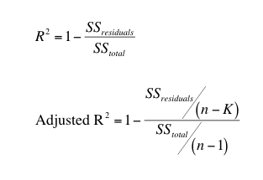

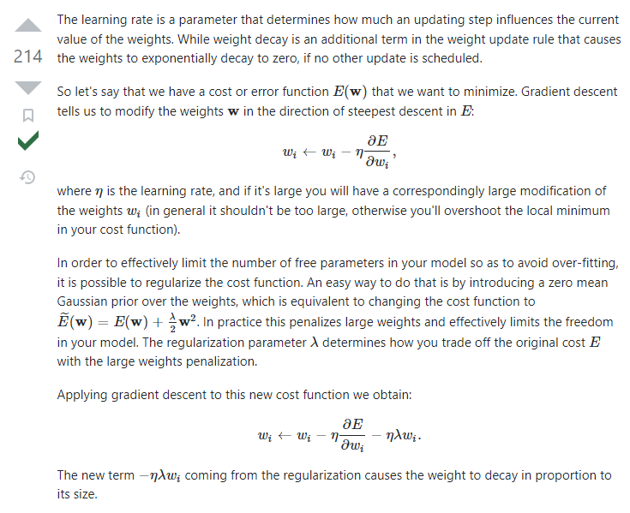

Probability density functions are always associated with continuous random variables. Continuous variables, are variables which can be measured, such as time, and length. However, a probability mass function is a function which only takes in discrete values for its random variable. However; in both cases the function must satisfy two conditions in order to be a PDF or PMF: 1)

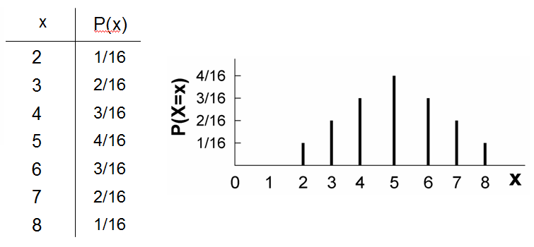

# DBSCAN Clustering — Explained

Clustering is a way to group a set of data points in a way that similar data points are grouped together. Therefore, clustering algorithms look for similarities or dissimilarities among data points. Clustering is an unsupervised learning method so there is no label associated with data points. The algorithm tries to find the underlying structure of the data.

There are different approaches and algorithms to perform clustering tasks which can be divided into three sub-categories:

* Partition-based clustering: E.g. k-means, k-median
* Hierarchical clustering: E.g. Agglomerative, Divisive
* Density-based clustering: E.g. DBSCAN

# ****Density-based clustering****

Partition-based and hierarchical clustering techniques are highly efficient with normal shaped clusters. However, when it comes to arbitrary shaped clusters or detecting outliers, density-based techniques are more efficient.

# ****DBSCAN algorithm****

DBSCAN stands for **d**ensity-**b**ased **s**patial **c**lustering of **a**pplications with **n**oise. It is able to find arbitrary shaped clusters and clusters with noise (i.e. outliers).

The main idea behind DBSCAN is that a point belongs to a cluster if it is close to many points from that cluster.

There are two key parameters of DBSCAN:

* **eps**: The distance that specifies the neighborhoods. Two points are considered to be neighbors if the distance between them are less than or equal to eps.
* **minPts:** Minimum number of data points to define a cluster.

Based on these two parameters, points are classified as core point, border point, or outlier:

* **Core point:** A point is a core point if there are at least minPts number of points (including the point itself) in its surrounding area with radius eps.
* **Border point:** A point is a border point if it is reachable from a core point and there are less than minPts number of points within its surrounding area.
* **Outlier:** A point is an outlier if it is not a core point and not reachable from any core points.

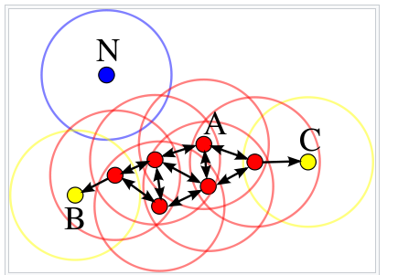

*The distance between points is determined using a distance measurement method as in k-means algorithm. The most commonly used method is euclidean distance.*

By applying these steps, DBSCAN algorithm is able to find high density regions and separate them from low density regions.

A cluster includes core points that are neighbors (i.e. reachable from one another) and all the border points of these core points. The required condition to form a cluster is to have at least one core point. Although very unlikely, we may have a cluster with only one core point and its border points.

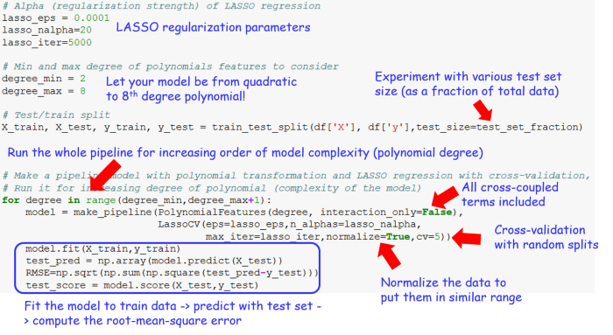

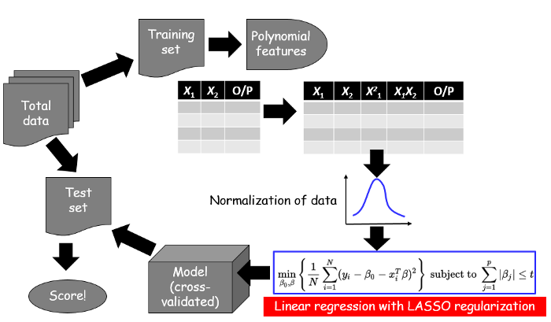

The answer lies in the fact that **using LASSO regression, we are essentially eliminating the higher-order terms in the more complex models**.

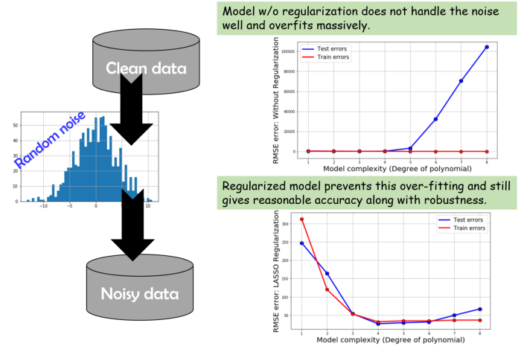

df['FuncApplied'] **=** df['col2']**.**apply(testfunc)

print(df)

df['FuncApplied']**.**apply(**lambda** x: np**.**sqrt(x))

# Hierarchical Clustering

Hierarchical clustering involves creating clusters that have a predetermined ordering from top to bottom. For example, all files and folders on the hard disk are organized in a hierarchy. There are two types of hierarchical clustering, Divisive and Agglomerative.

**Divisive method**

In this method we assign all of the observations to a single cluster and then partition the cluster to two least similar clusters. Finally, we proceed recursively on each cluster until there is one cluster for each observation.

**Agglomerative method** In this method we assign each observation to its own cluster. Then, compute the similarity (e.g., distance) between each of the clusters and join the two most similar clusters. Finally, repeat steps 2 and 3 until there is only a single cluster left.

[**https://github.com/tirthajyoti/Machine-Learning-with-Python/blob/master/Clustering-Dimensionality-Reduction/Hierarchical_Clustering.ipynb**](https://github.com/tirthajyoti/Machine-Learning-with-Python/blob/master/Clustering-Dimensionality-Reduction/Hierarchical_Clustering.ipynb)

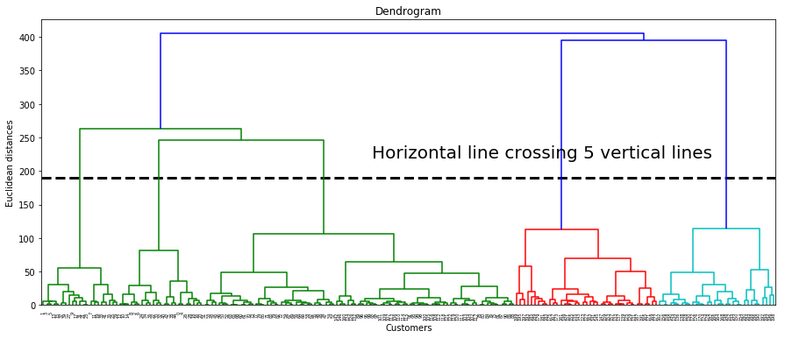

Each word is a **node** in the Dependency graph. The relationship between words is denoted by the edges. For example, “The” is a determiner here, “children” is the subject of the sentence, “biscuits” is the object of the sentence, and “cream” is a compound word that gives us more information about the object.

The arrows carry a lot of significance here:

* The **arrowhead** points to the words that are **dependent** on the word pointed by the **origin of the arrow**
* The former is referred to as the **child node** of the latter. For example, “children” is the child node of “love”
* The word which has no incoming arrow is called the **root node** of the sentence

**All we have to check is which dependency paths are common between multiple sentences. This method is known as Subtree matching.**

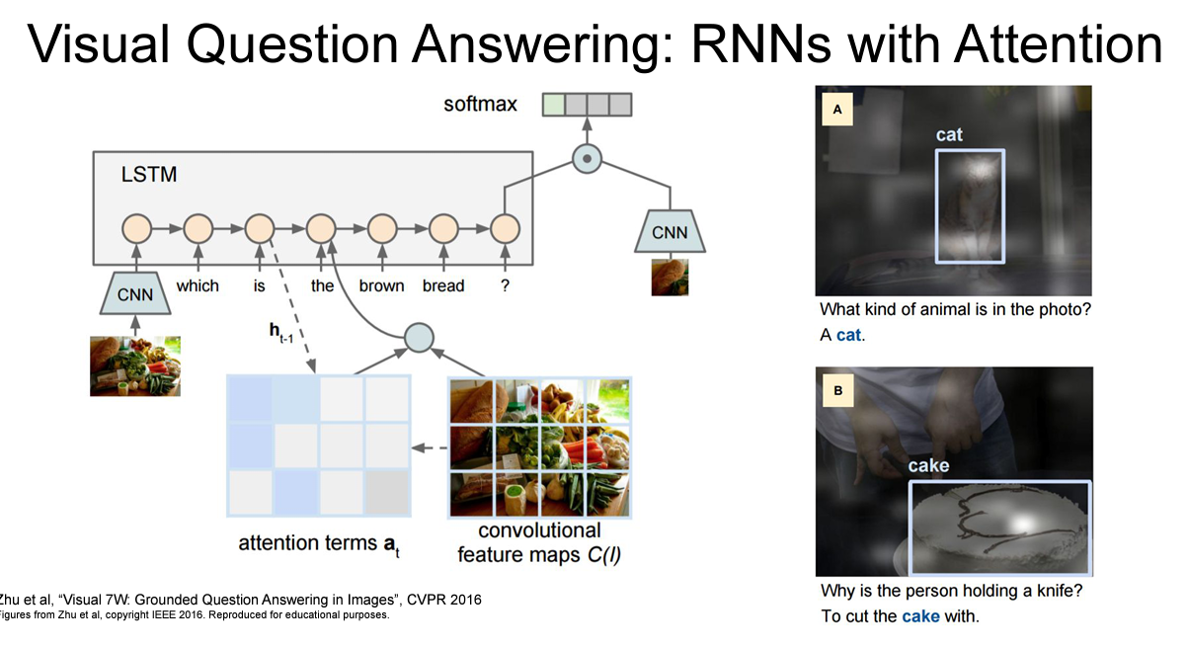

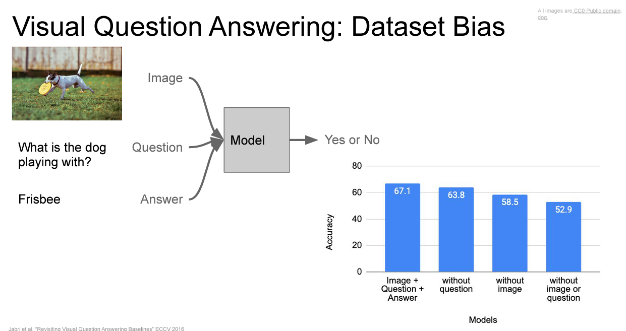

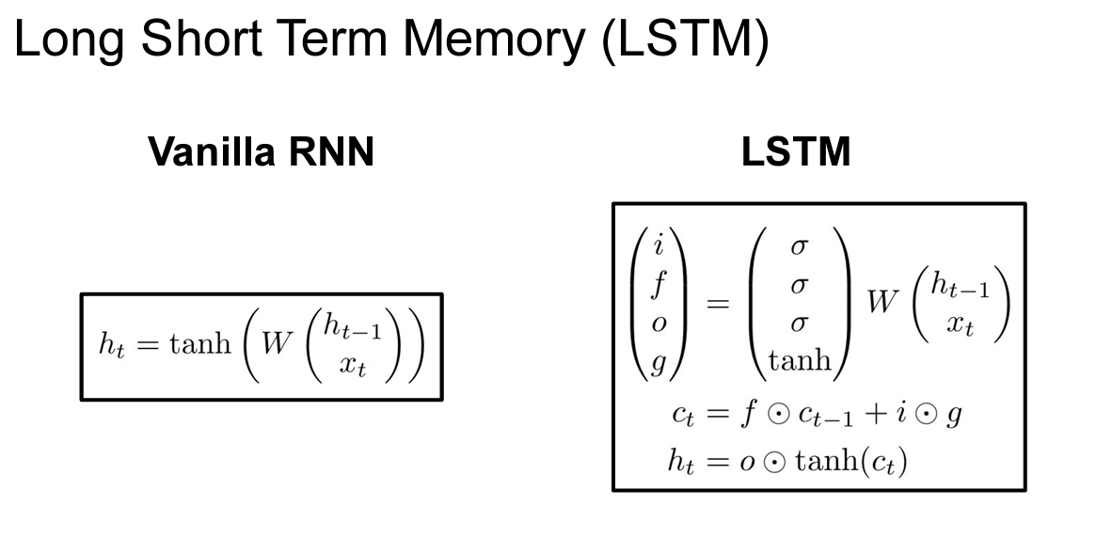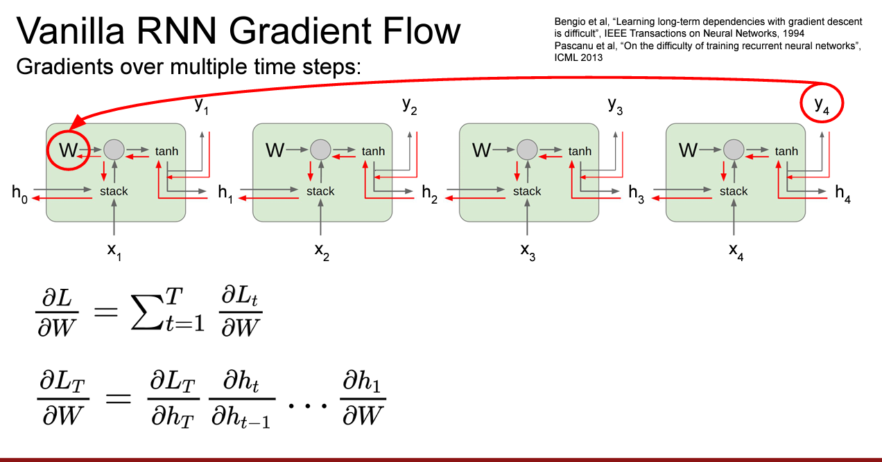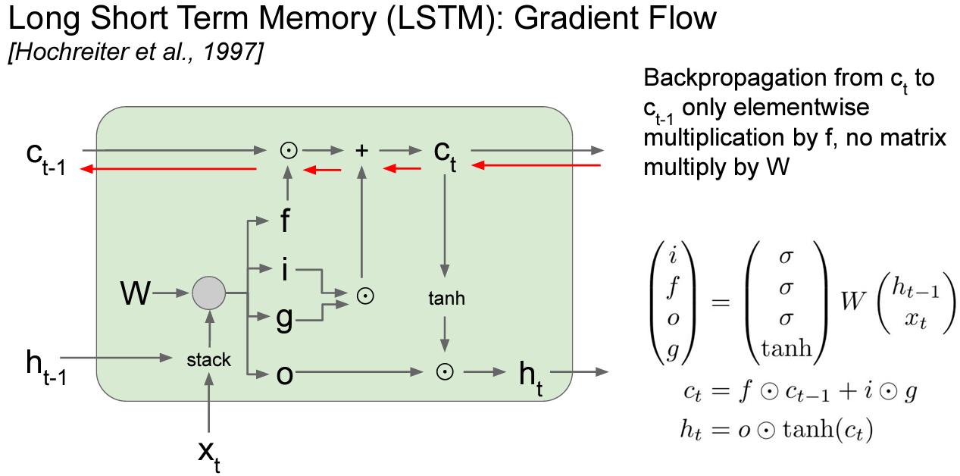

**LSTM doesn’t guarantee that there is no vanishing/exploding gradient, but it does provide an easier way for the model to learn long-distance dependenciesa**